Guru sharma video

**AWS Tutorials - 4 - Deployment Model of Clouds - Public Private and Hybrid Cloud**

Three type of aws cloud

1 public cloud(over the world koi be access kr sakta ha)

2 private cloud(is ko serf private user he acces kr sakta ha)

3 hybrid cloud

Video num 5 pricing model

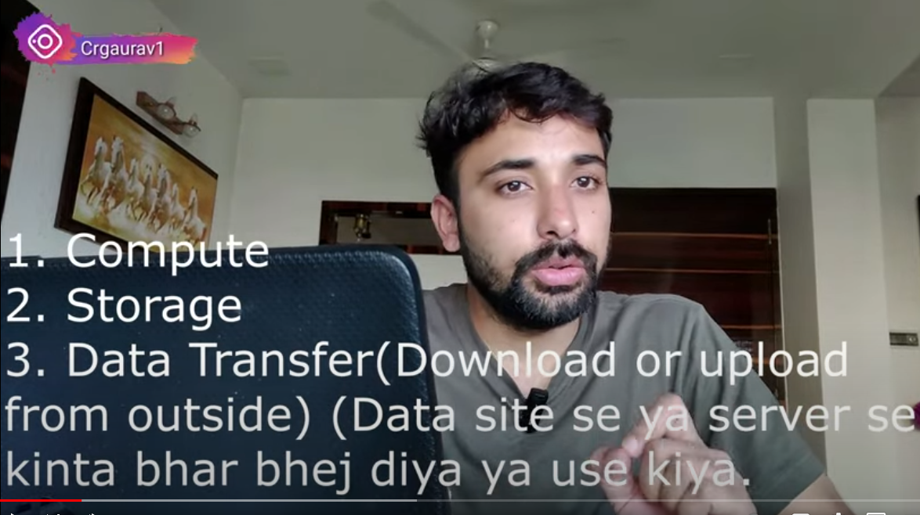

3 ways that aws send money

1. Compute mean ya ha ka ap na kitna computer ya cpu chlayaaa ha.
2. Storage sa murad ya ha ka ap na kitne storage bani ha or uss hisab sa passa la ga .
3. Data transfer (isss sa murad ya ha ka ap na server sa kitna data bahir baja ha ya kitne bar baja ha.

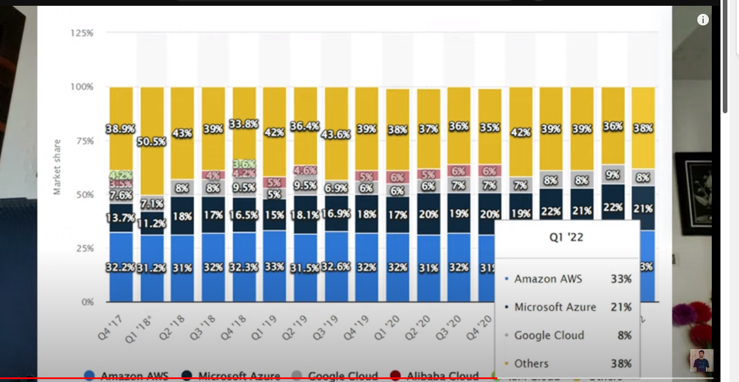

Video turtorail about region 6

Regions have name and code

Avalibilty zone ka name or code hota ha

Ak region ka andr 3 avalibility zone hota ha

(Ap-south 1a

Ap south 2b

Ap south 3c) etc are avalibilty zone or in ka andr data store hota ha agr ak zone ma masla ho to dosra ma data ho ga ..

Or sara region ka server aps ma connect rahta ha or in ke transfer speed 100gb pr second hoti ha through ocean wire.

Or har region ka code name hota ha

Region ka andr hum limit laga sakta ha ka

Hamara data Pakistan ma raha ya kisse or country ka data dosree country ma na shara ho.

AWS Tutorials - 7 - What/Why is AWS Availability Zones | AWS Global Infrastructure

Availability zone

Avalibilty zone iss lea bnaya jata ha ka agr ak data center ma kio be masle aaa jay to dosraa data center ma data store jo jaya

Local zone

**AWS Tutorials - 8 - What/Why is Local Zones | Local Zones | AWS Global Infrastructure**

**1 What is local zone**

Type of zone

Global zone//is ma hum poree world ma data da sakta ha

Local zone //ma data khali uss country ko data dea jaya ga jhan user server ak he country ma ho ga

Matlb don ak he mulk ma ho//

Hum koi be movie Netflix sa dekhta ha to hum wo nearest zone ya local zone sa mill rahe ho gee

**AWS Tutorials - 9 - Create AWS Account | Create AWS Free Tier Account ( in Hindi )**

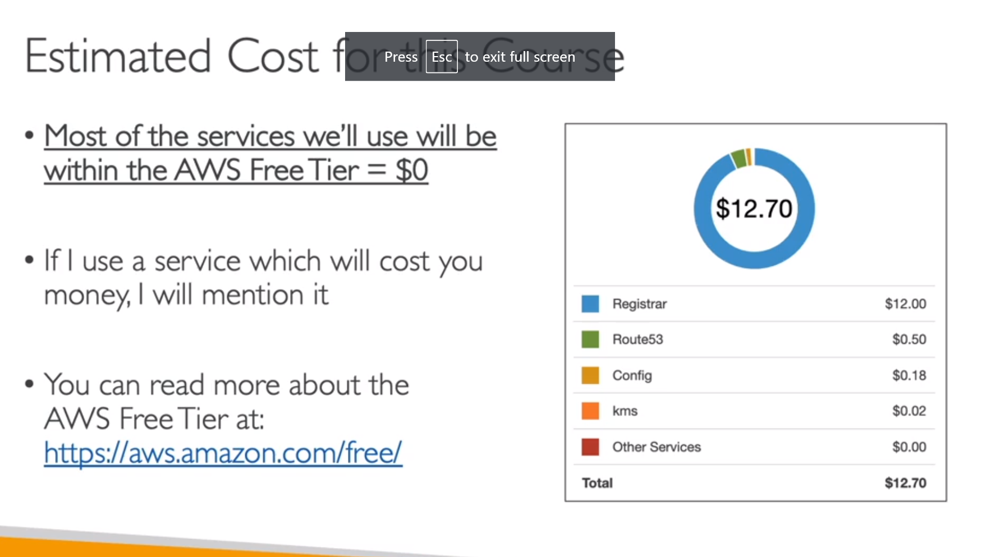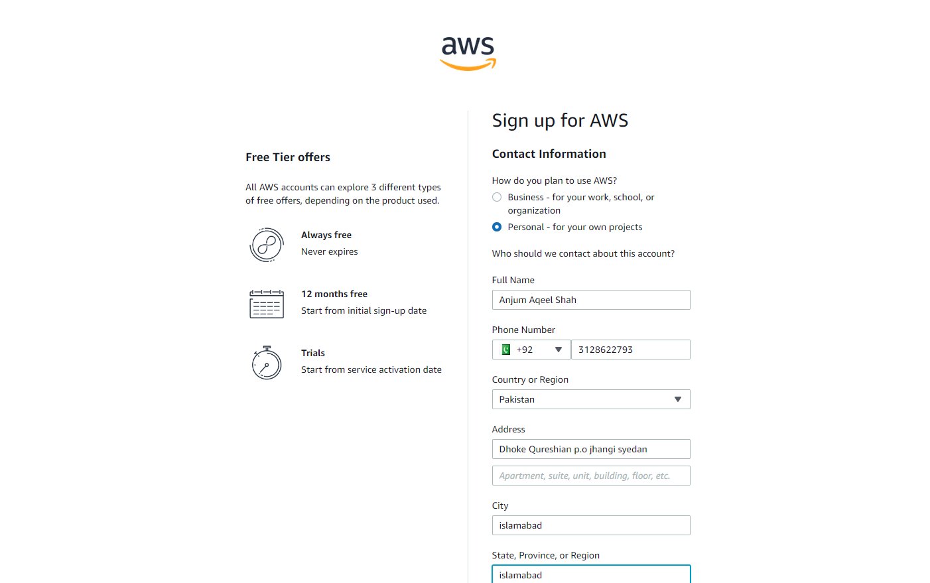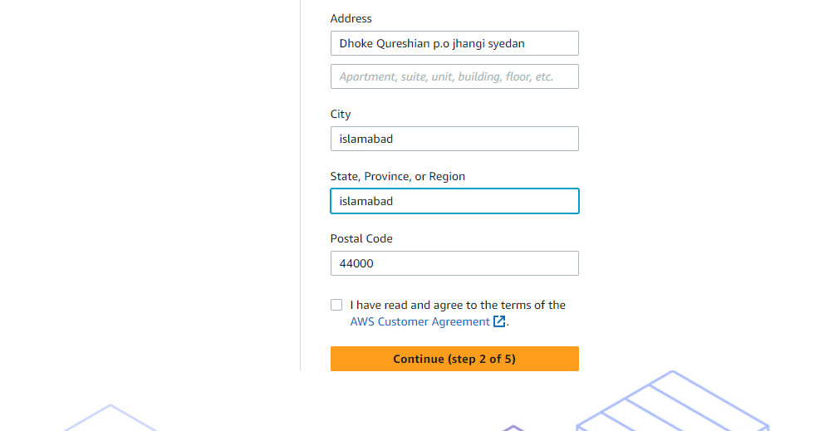 For downloading of codes and slides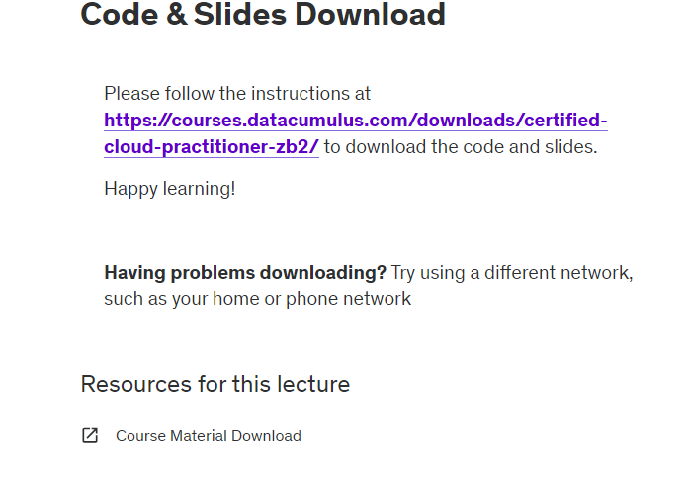

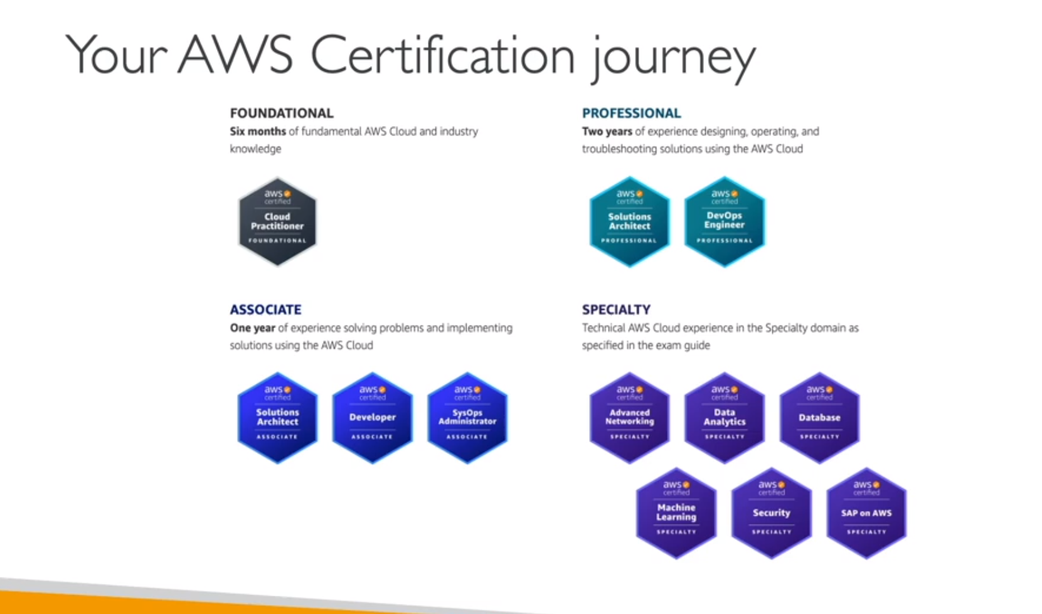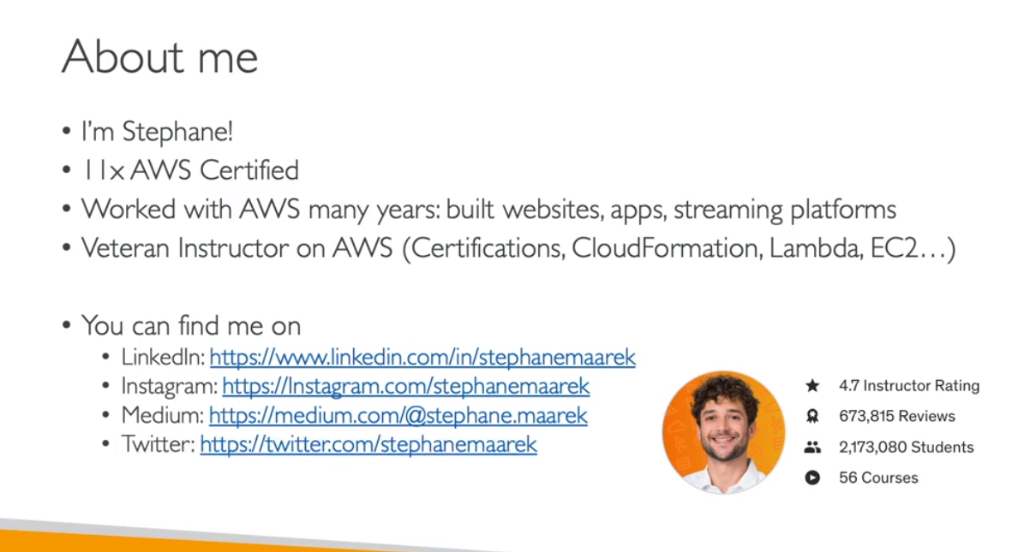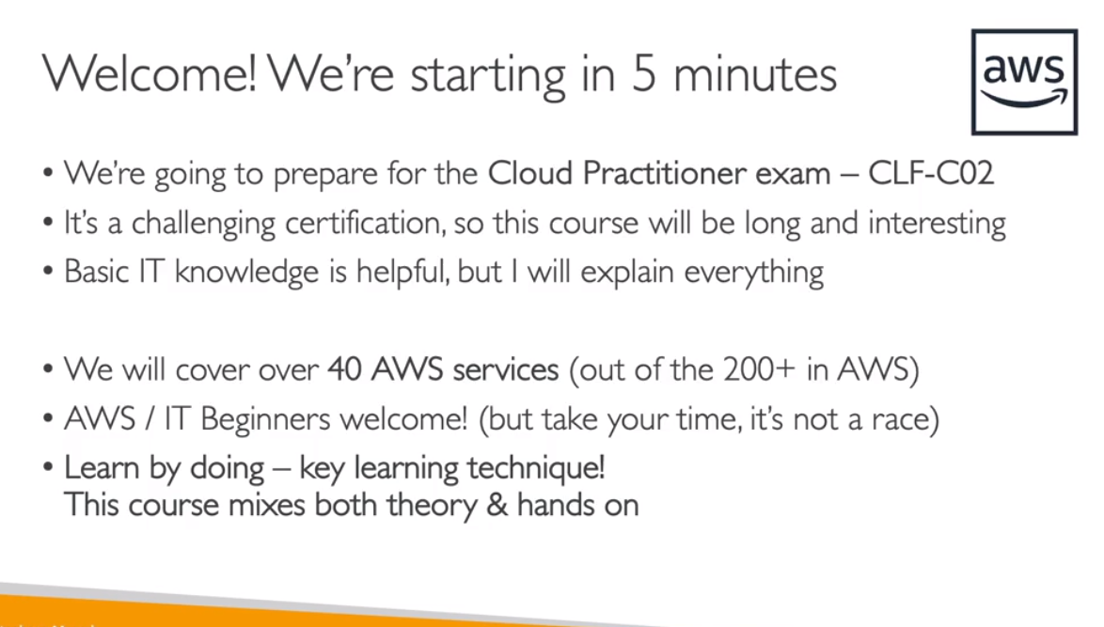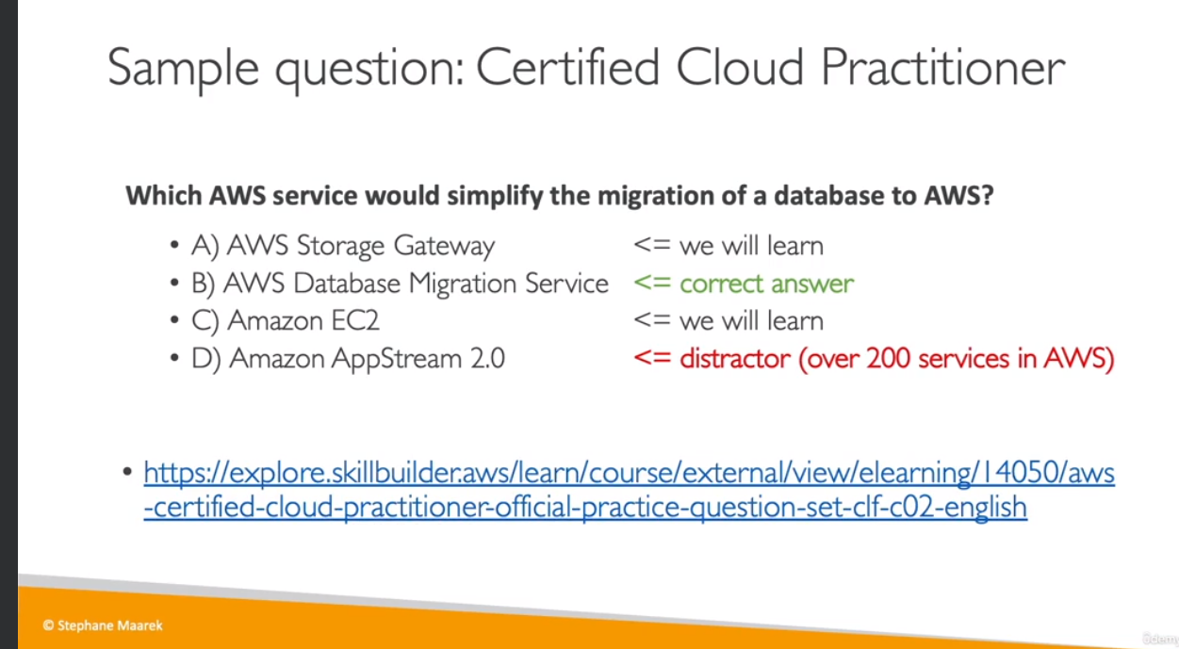

As of my last knowledge update in January 2022, here are some of the Amazon Web Services (AWS) offerings. Please note that the number of services may have changed, and AWS may have introduced new services or updated existing ones since then. For the latest and most accurate information, it's recommended to check the official AWS website.

1. Amazon EC2
2. Amazon S3
3. Amazon RDS
4. Amazon Lambda
5. Amazon DynamoDB
6. Amazon CloudFront
7. Amazon Elastic Beanstalk
8. Amazon Redshift
9. Amazon VPC
10. Amazon CloudWatch
11. Amazon Route 53
12. Amazon Polly
13. Amazon SNS
14. Amazon SQS
15. Amazon Kinesis
16. Amazon ECS
17. AWS Glue
18. Amazon EMR
19. AWS Lambda
20. Amazon Cognito

This is just a small selection, and there are many more AWS services covering a wide range of functionalities to meet various cloud computing needs. For the most current and complete list, refer to the official AWS documentation.

**10th video AWS Tutorials - 10 - Create First EC2 Instance | EC2 Instance Creation in AWS**

What is ec2 and how to use ?

Ec2 stands for elastic compute cloud

Ec2 ma server rent pr lena hota ha

1 go to ec2

2 enter name (first name)

3 then select ubantu

4 then select instance type

5 then enter key pair or create new key pair

6 then network settings

7 then select root space

8 then launch instance

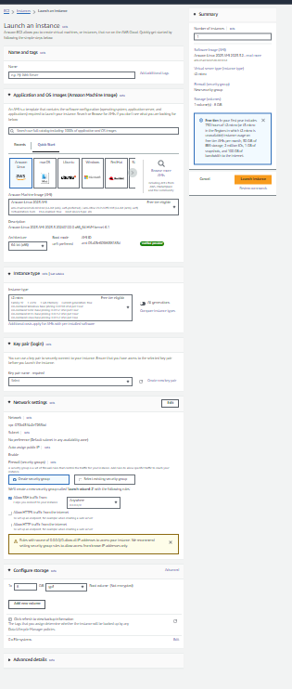

# AWS Tutorials - 11 - Access EC2 Instance From Windows Machine | EC2 Instance Connect ( in Hindi )

# 

# 

# Is ma hum kasa remotely acces kr skata ha apna instance ko

# First in window 10

# Jhan pr hum na key file download ke ha

# Udr jana ha

# Fr type cmd karna ha

# Fr uss ka bad space dane ha

# Fr instance pr ana ha jo hum na create kea ha

# Uss ka upr click karna ha

# Fr connect pr click karna ha

# Us massh client pr jana ha

# Fr pora code utana ha

# Then paste in cmd

# Fr command chala he

# Fr yes type karna ha

# Command chalaa ge

# {ssh -i "first-instance.pem" [ubuntu@ec2-18-183-83-1.ap-northeast-1.compute.amazonaws.com](mailto:ubuntu@ec2-18-183-83-1.ap-northeast-1.compute.amazonaws.com)

# Fr yes karna ha type

# { cat /etc/os-release/is sa version btay ga

# { free -m /is sa available space etc btay ga

# {lscpu/is sa btay ga kitna cpu ha

# { df -h /is sa kitne ram volumeha

# { ip a/is sa apna ip address btay ga

# Now in linus

# 1 go to instance

# 2 then select instance

# 3 and then click on connect button

# 4 now open ec2 instance connect

# 5 necha connect button ho ga us pr click karna ha

# 

How to create ec2 instance

1 first search ec2

2 then go to launch instance

3 then add name (e.g syedanjumshah=aws)

4 then select ubantu

5 then select first option

6 then check instance type

How to eccess the ec2 buccet

1 go to instance where you can store the key (ec2>> instance)

Jiss folder ma ho wha cmd chala Ga

1 first create instance

2 then click on connect button

3 then goto ssh client

4 open cmd where file is download

5 then select cmd and add space first in cmd and paste the command ssh client

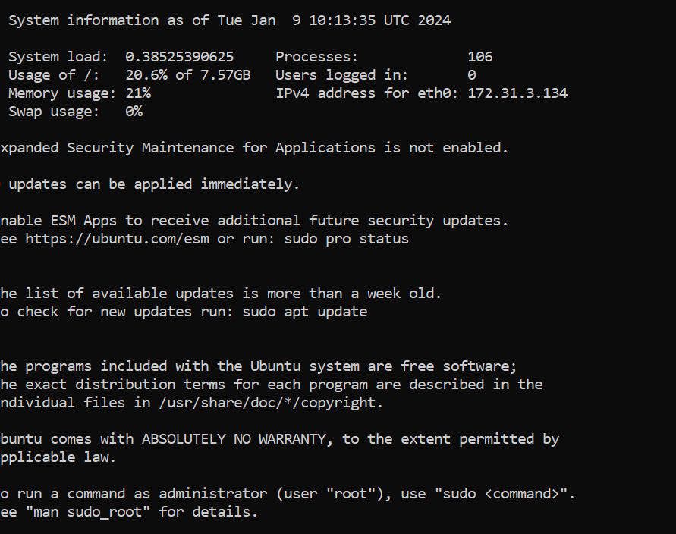

/// fr ya Aa gay ga

1 then add this command to check(cat /etc/os-release)

2 camman(free -m)

3 cammand(lscpu)

4 clear

5 cammand( df -h)

6 command( ip -a)

7 command (ip a)

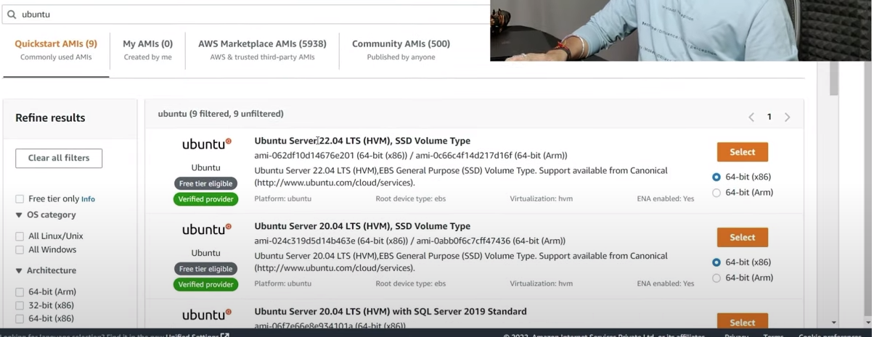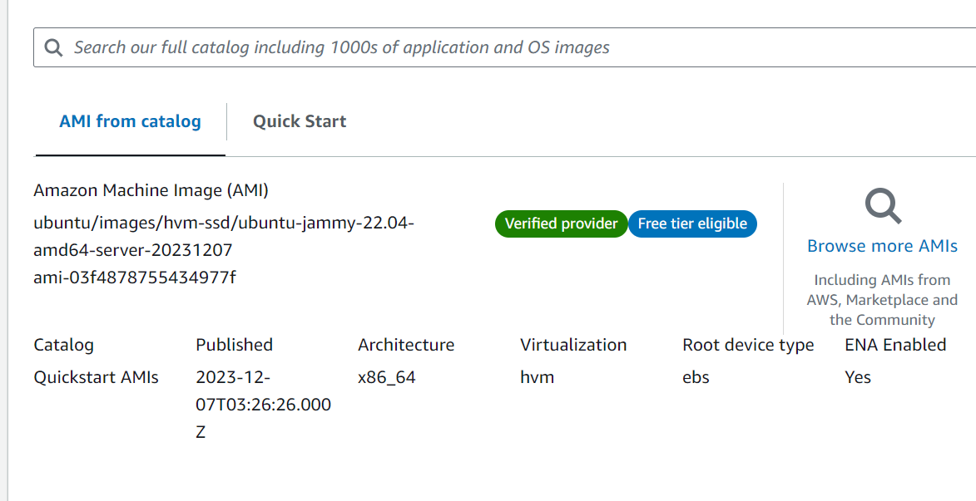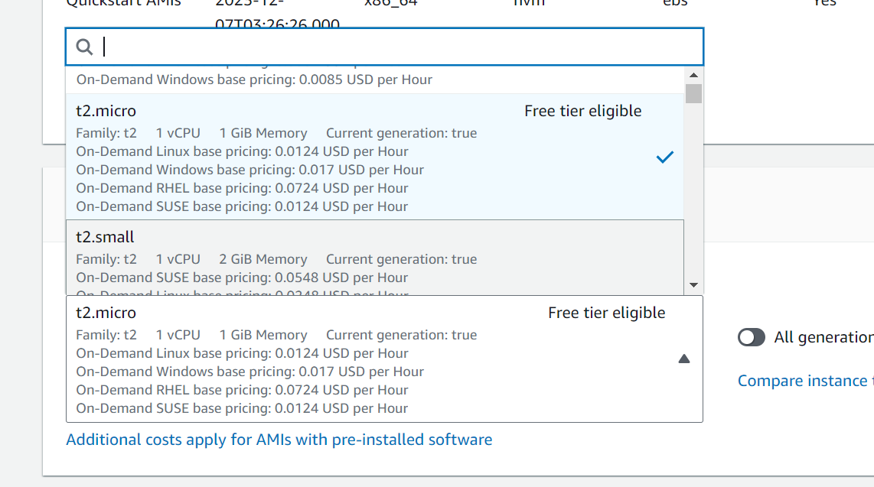

**12 video turturiolAWS Tutorials - 12 - Access EC2 Instance From Linux Machine | EC2 Instance Conn**

Is ma linux machine pr kam karta ha video dakhi ha mgr practicle nai kea

How to access linux machine

`1 (Pwd) command for linux

2 ls

3 -lh

**13 video turtorial AWS Tutorials - 13 - Install Nginx in EC2 Instance | Deploy Sample Application In EC2**

Install Nginx in EC2 Instance

1 go to instance

2 jo instance ap ka bana ho ha uss ko click kr ka connect carna ha

3 connet ka option khola ga to us ma iss terha ke pic khola ge

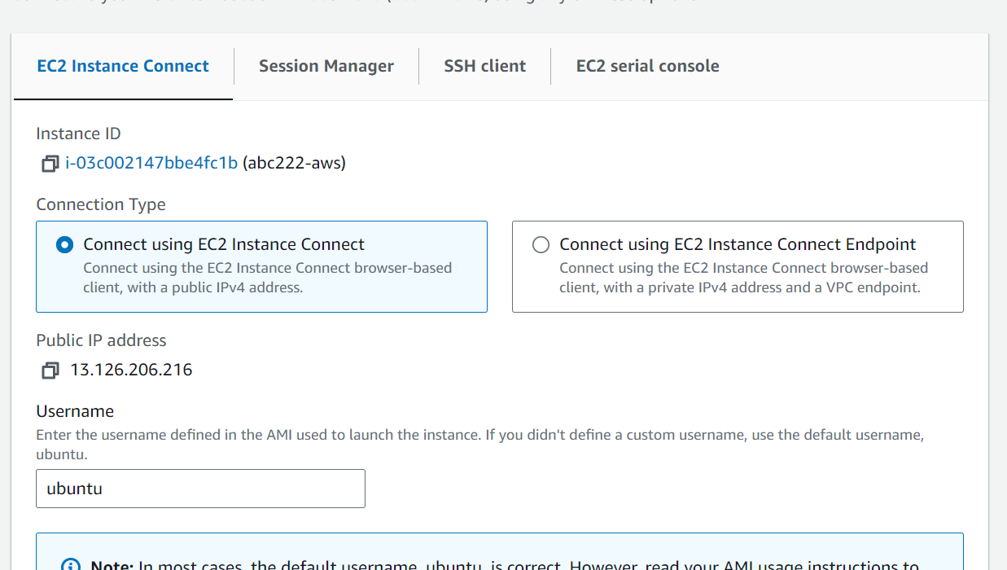

4 Iss ka necha connect ka button ho ga connect pr click karta he new command wala page khol gay ga

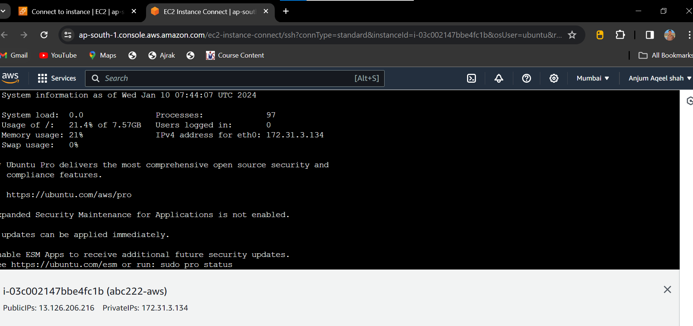

///

1 Sudo -i

2 apt-get update

3 Nginx -t

4 sudo apt-get install nginx //this for installing

5 then press y

6 service nginx status

7 curl localhost

8 cd /var/www/html/

Ls

Cat index.nginx-debian.html

9 echo “welcome to ttdktd”> index.html

Curl localhost

// is sa output sa ga 9 ke

**AWS Tutorials - 14 - Bootstrap Script in EC2 Instance | User Data In EC2 ( in Hindi )**

Bake sare instance create karna ha

Us ma user detail ma iss jasa box aya ga to hum uss ma shell script dala ga

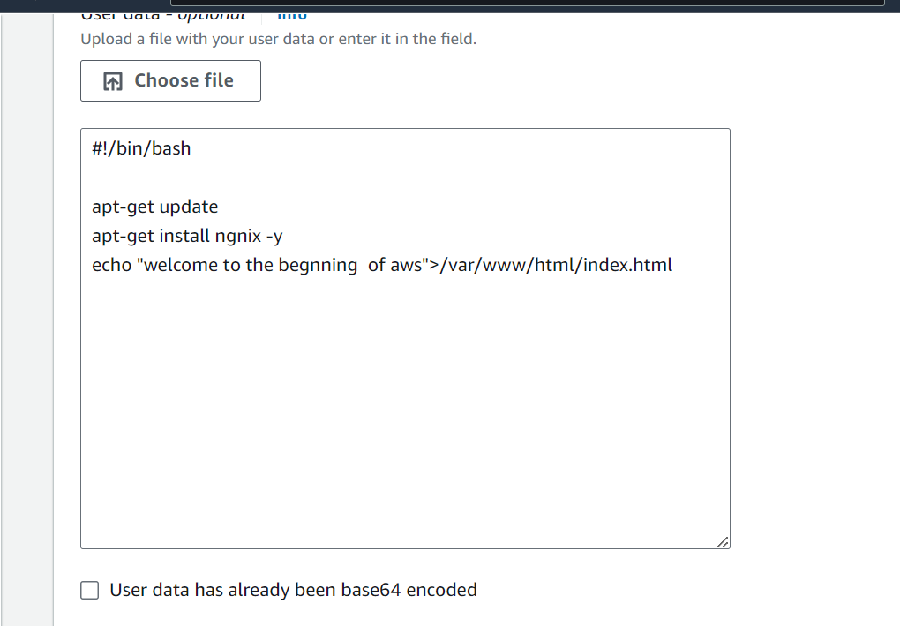

Error code ma

1 echo ka bad space dalne ha

2 > is sa phle space dalne ha

**AWS Tutorials - 15 - AWS Security Group | Security Group AWS ( in Hindi )**

What is security group

Is ma hum allow karsakta ha ka hum kisss port sa data ay or kisss port ka data block ho gay

//or hum koi be instance banata ha to default security group create ho jata ha

//ya do security group bnay ga

1 port2

2 port 80

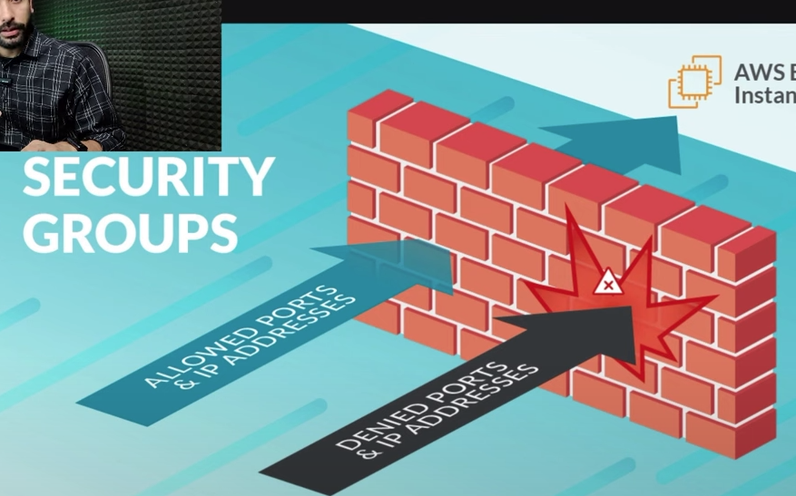

How to create security group

1 first go to instance dashboard

2 then go to security

3 security ma ja kr create security karna ha

4 fr name banana ha

5 ya lekhna ha(allow ssh to access developer)

6 vpc default raha ga

7 inbound rule(first (ssh)select karna ha

8 outbound rule ma sara data wo he raha ga

9 source ma ap bta sakta ha ka ap ka data ko kiss jaga sa access kr sakta ha

9.5 description ma kuch be dal sakta ha pr uss na koi chez nai dale

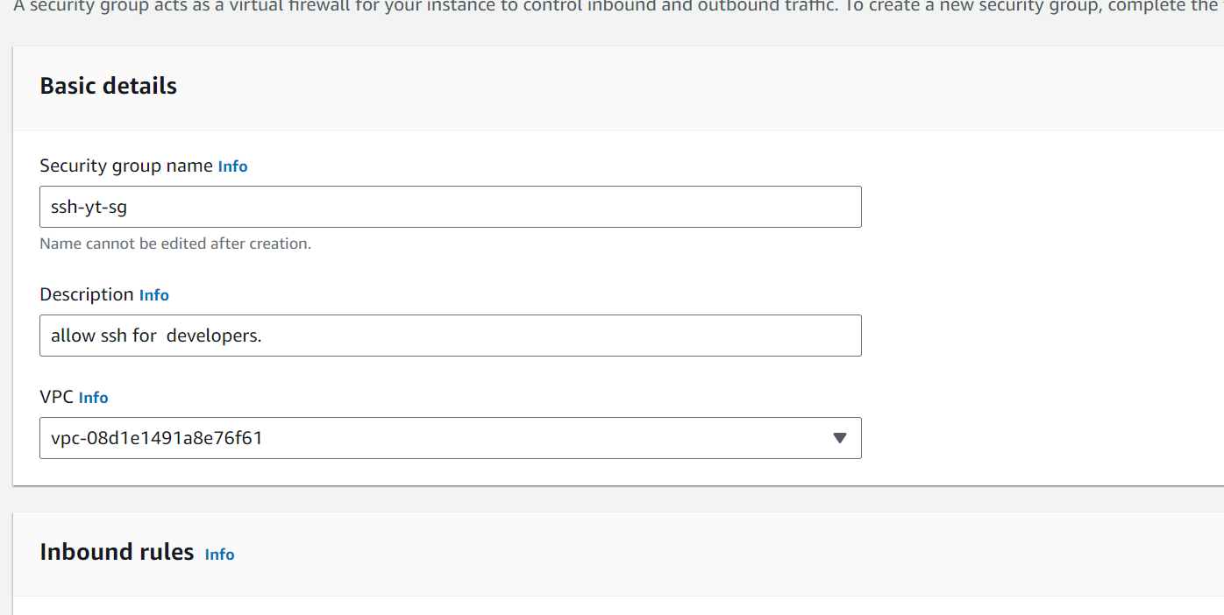

1 Inbound rule//jo jo rule instance ka upr poncho ga

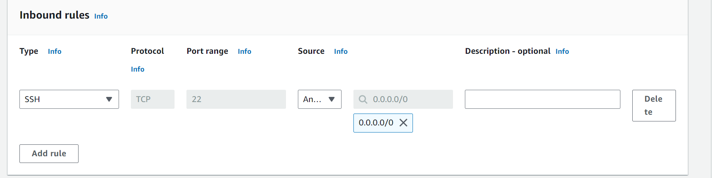

Or hum custom type be dal sakta ha(8080 )etc

2 Outbound rule//is ma ap ka instance kiss sa bahir bat communication kr sakta ha

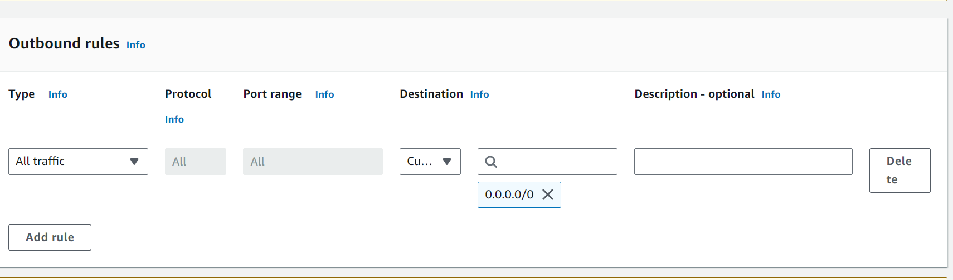

10 Then click on create security group

///////////

Jab dosre security banata ha to

1 inbound ma (http) select karta ha

///fr wo instance create karta ha

Instance ma network security >>ma select execting security group button ko click kr ka option select kar len ha

Fr launch instance kr leta ha //

Fr connect pr chala jata ha



{ nginx status

First wala security group block ho gya ha ab instance ko click kr ka

Action>security>change security groups >associated security group >select security>fr select kr ka> add asecurity group pr click karna ha>save

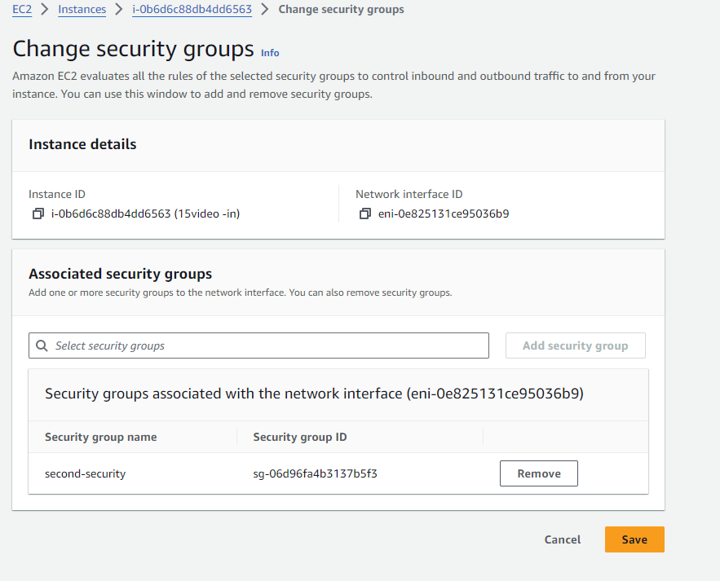

Jab hum dosra security group attach karta ha http wala to output aa jate ha

//fr instance or security delete kr dane ha

Ak instance ko hum multiple security attach kr sakta ha //

//Ak security group ko hum multiple instance attach kr sakta ha//

Command for connect

Hum ak security group banay ha jiss ma example

**AWS Tutorials - 16 - AWS EC2 Instance Type | Instance Type in AWS ( in Hindi )**

Is video ma huma instance type ka bara ma btataa ha ka kiss time kiss ko use karna ha //

//kiss time pa huma kon sa instance type huma select/use karna ha //

1 go to instance

2 and

//Hum iss ma different system bna sakta ha different pc (mac, t2 ma kam kr sakta ha)

This is instance types

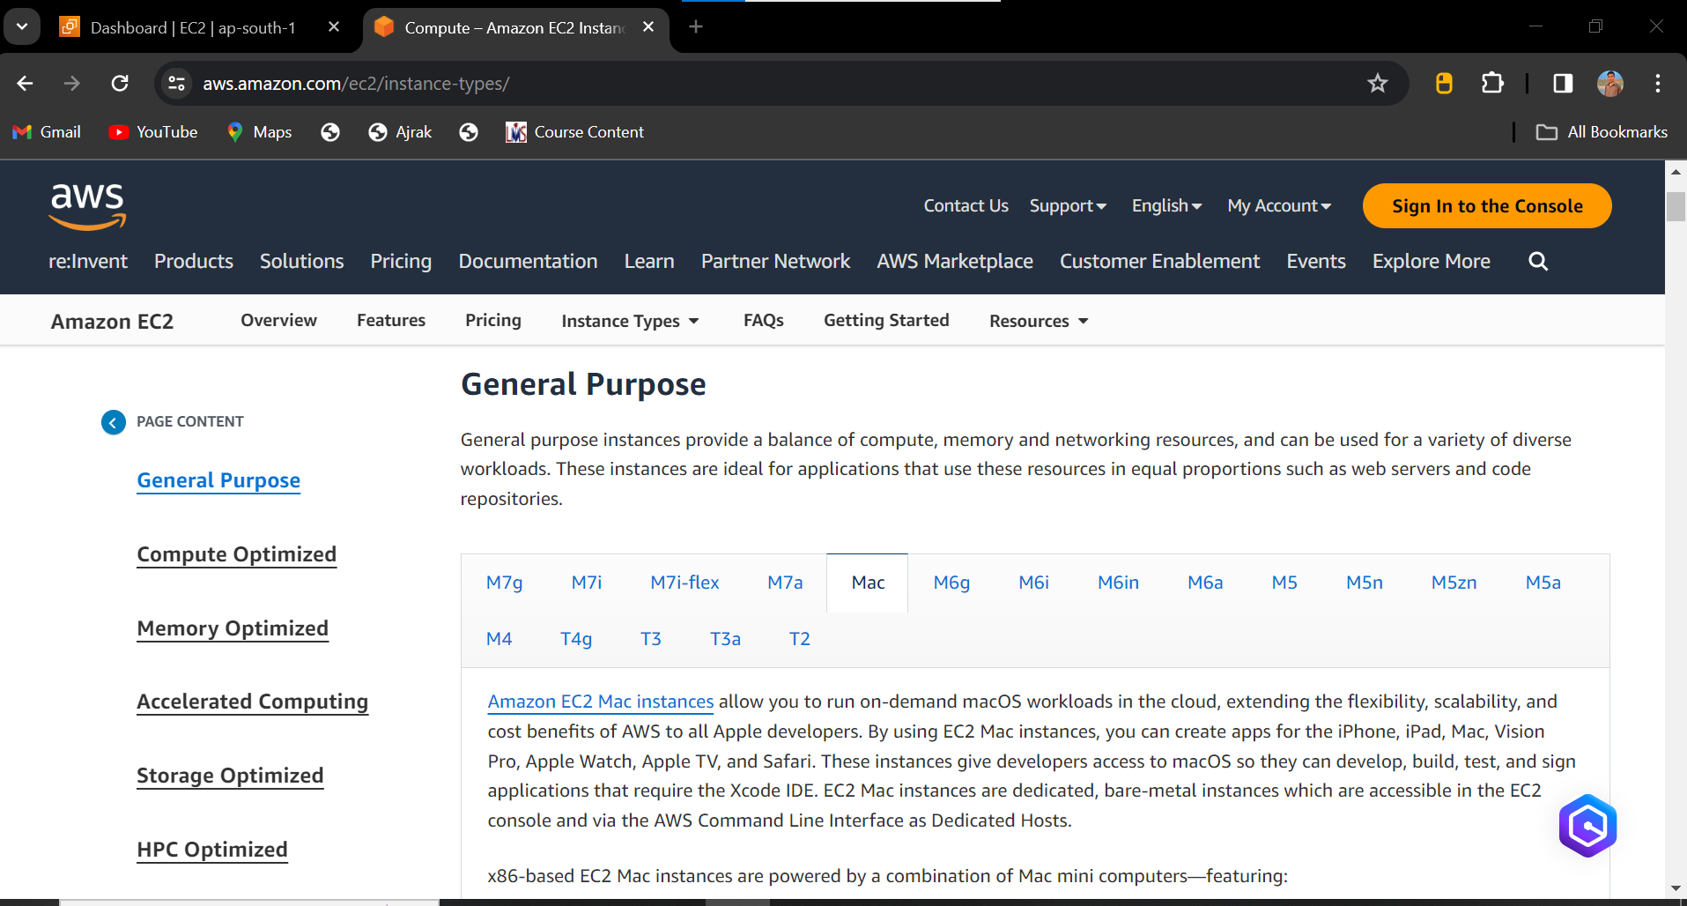

Instance type

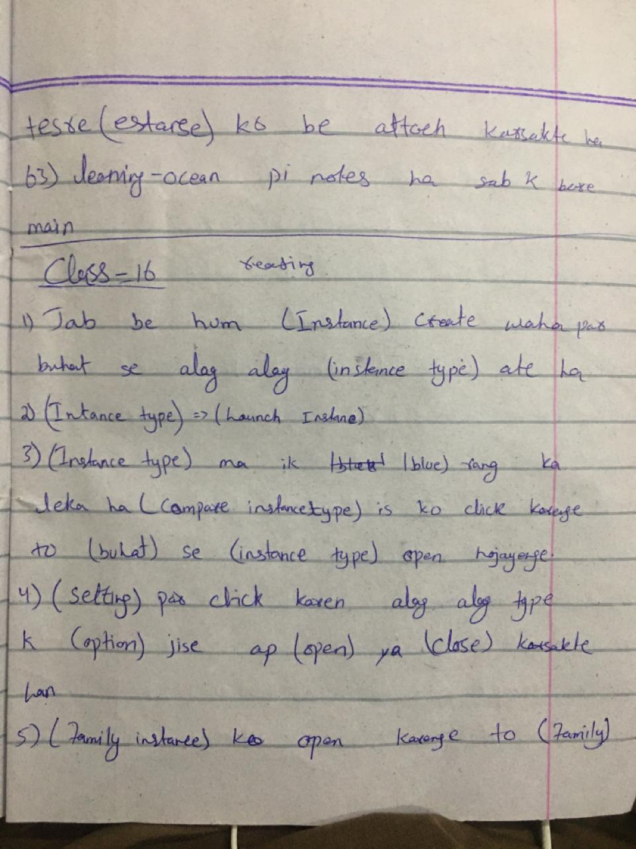

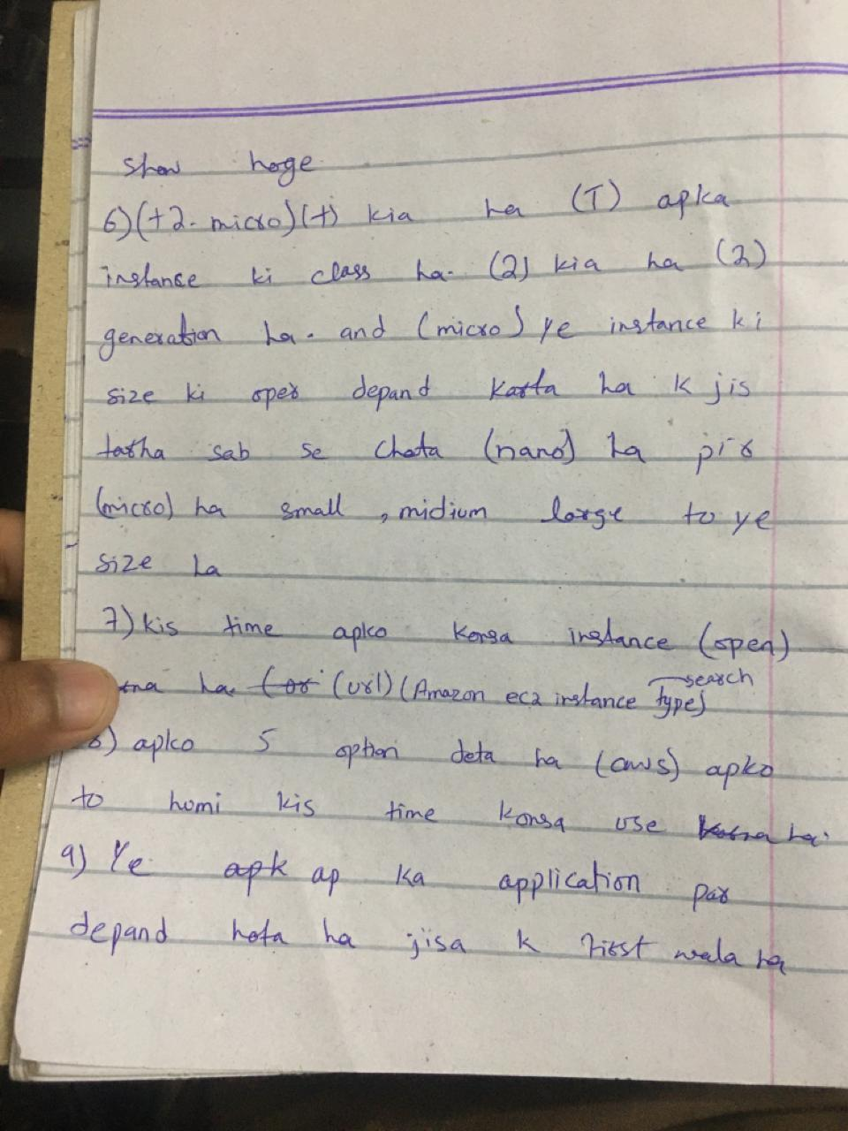

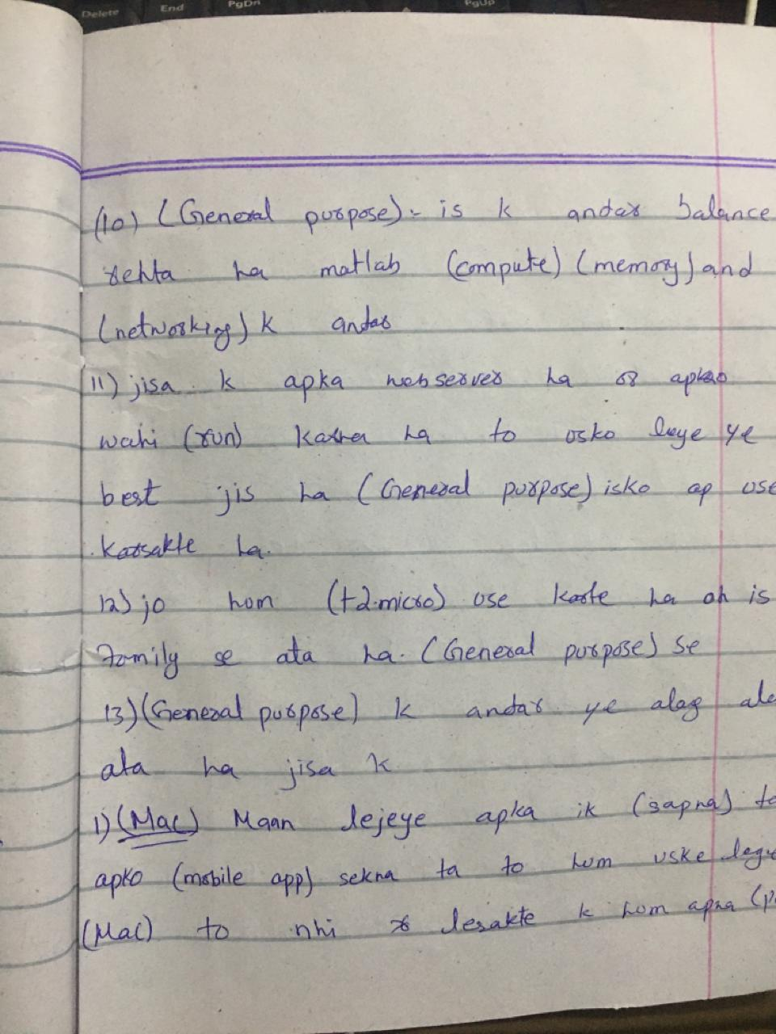

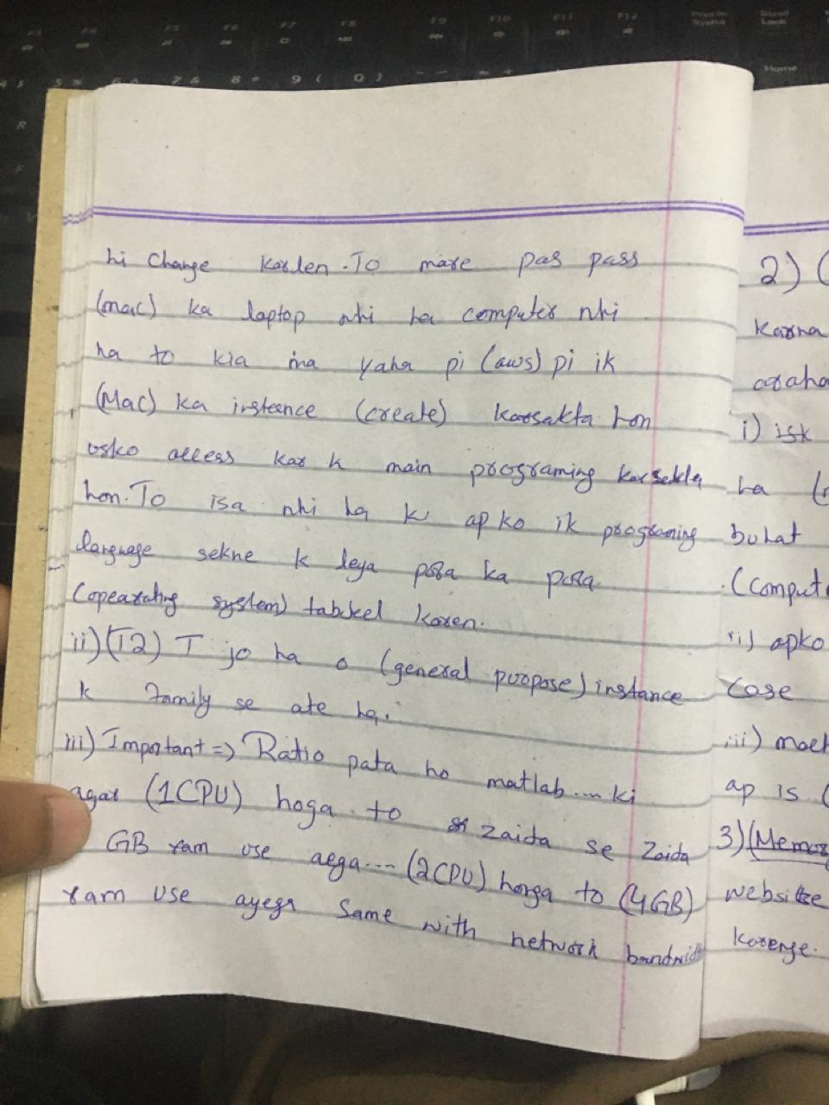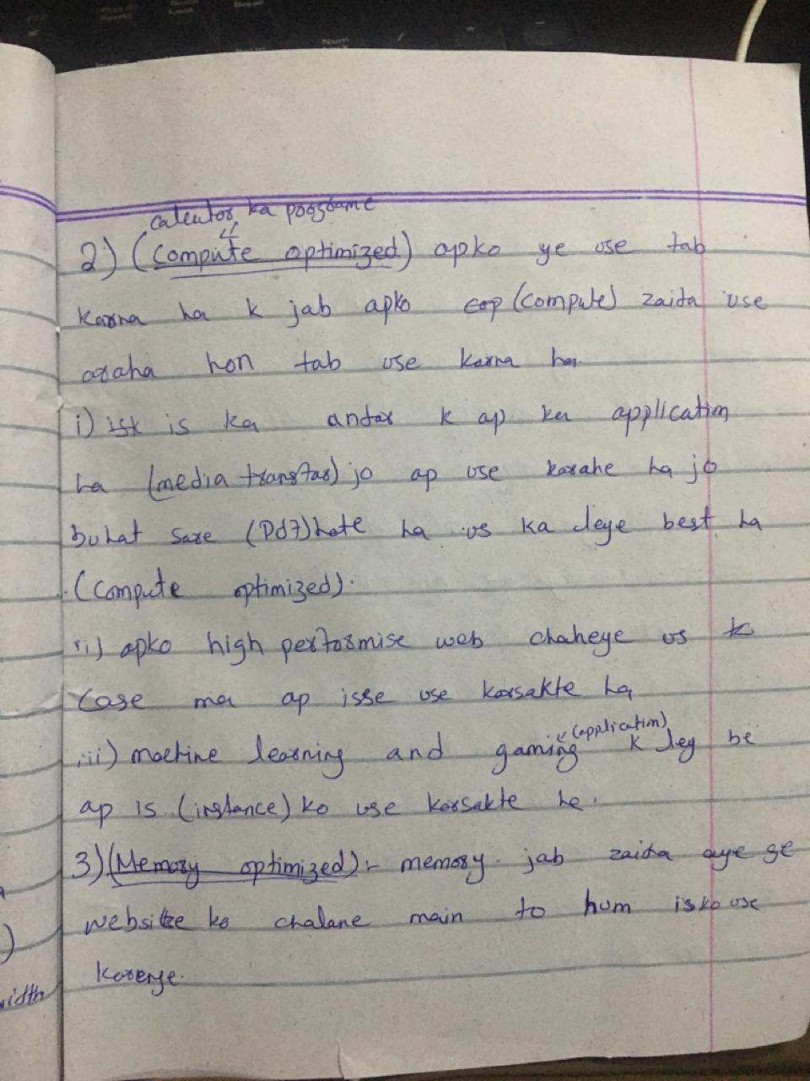

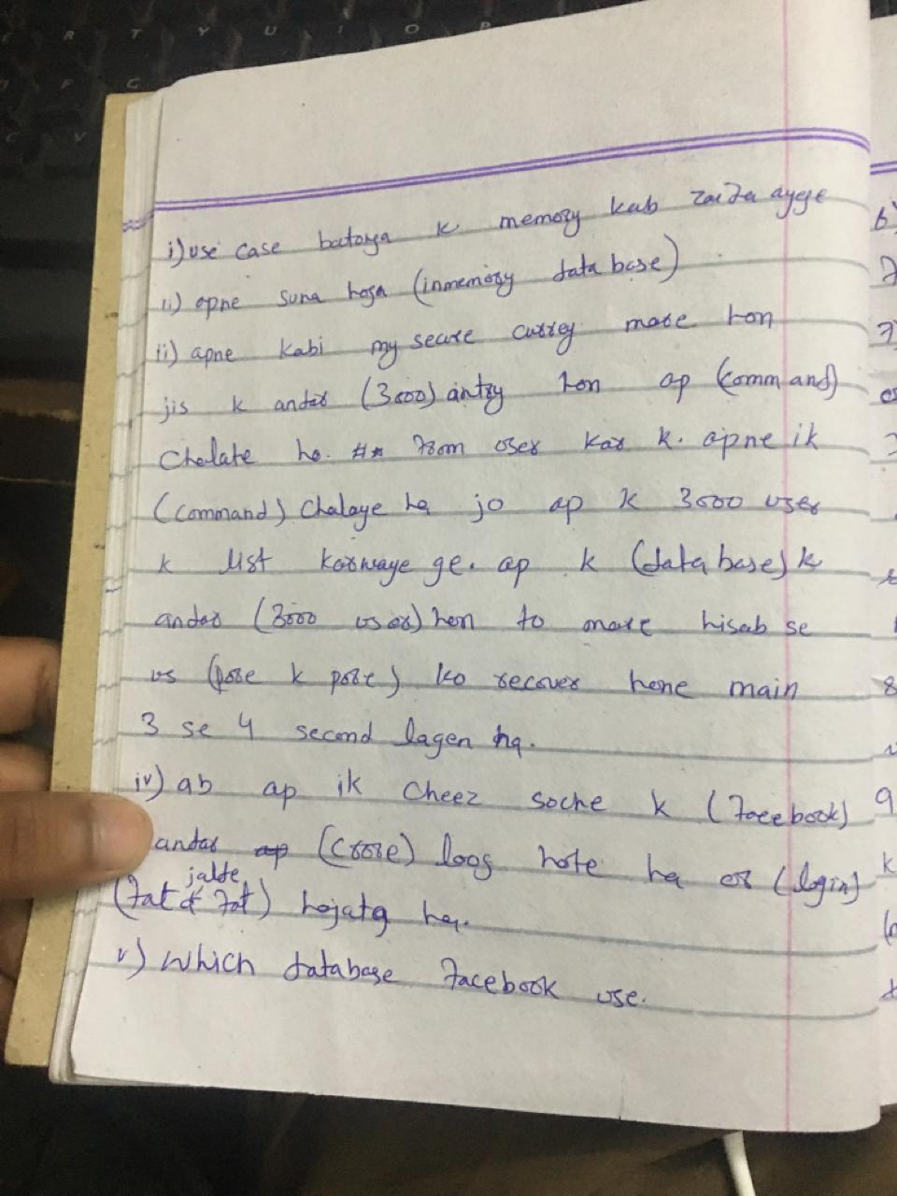

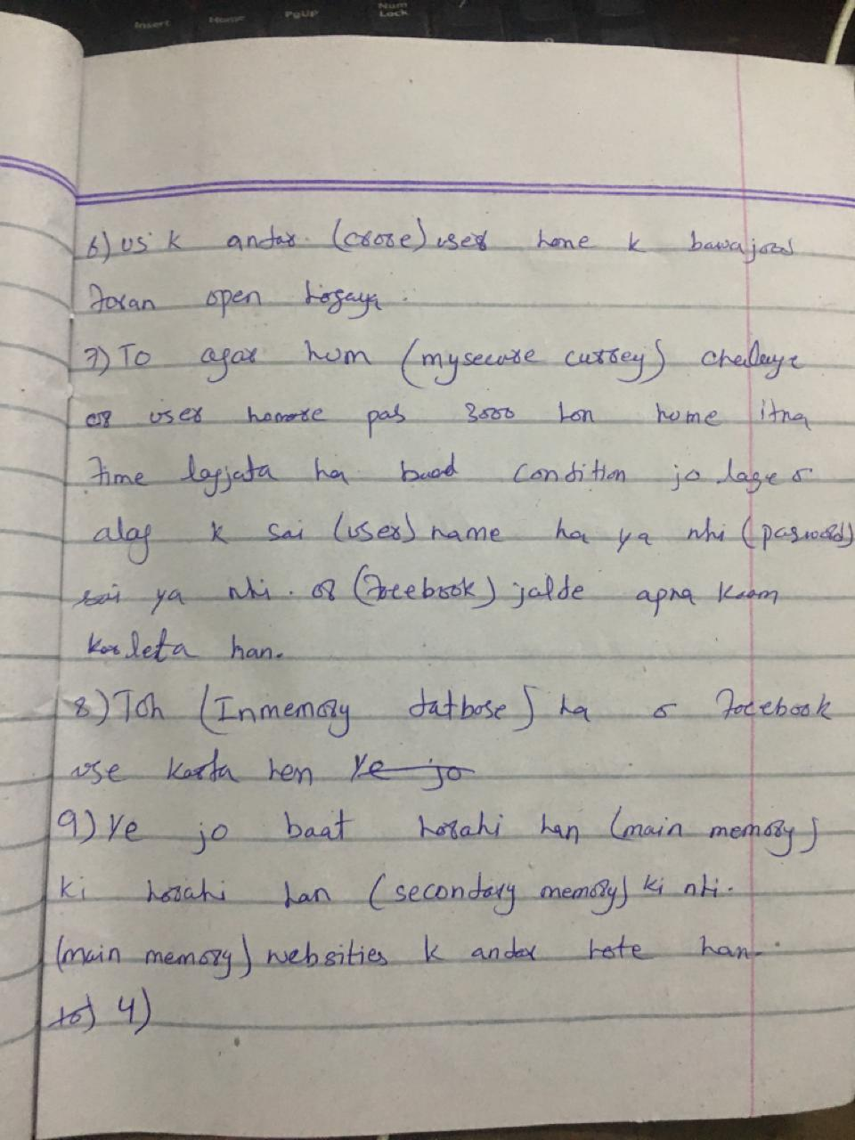

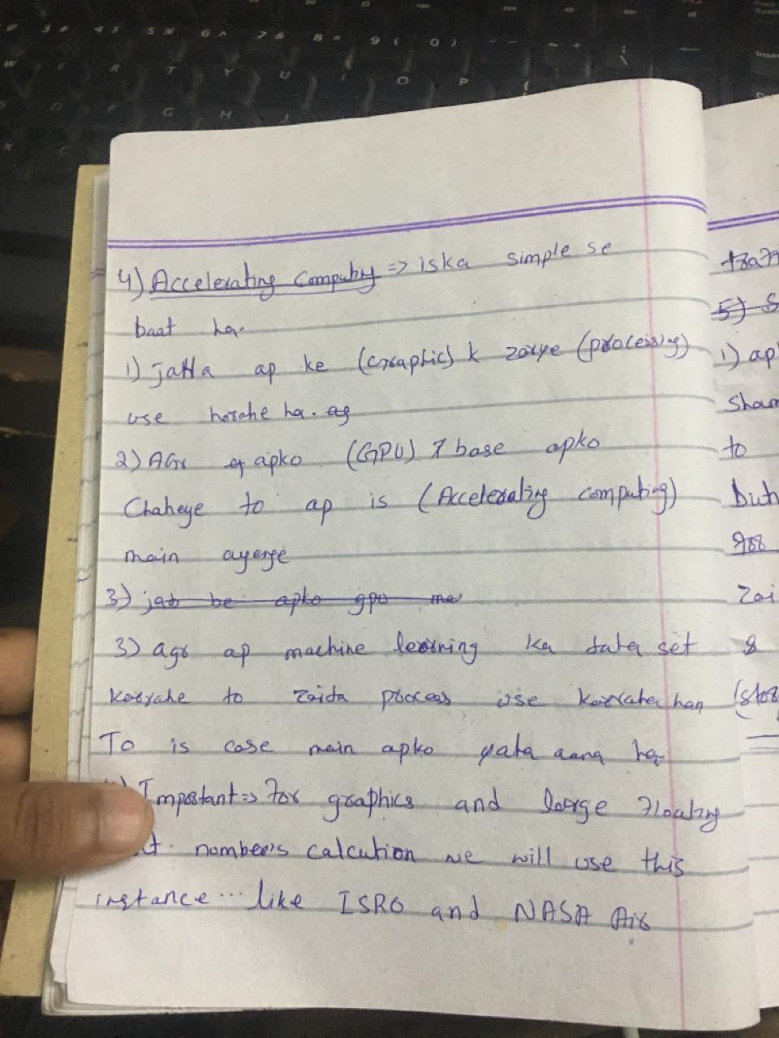

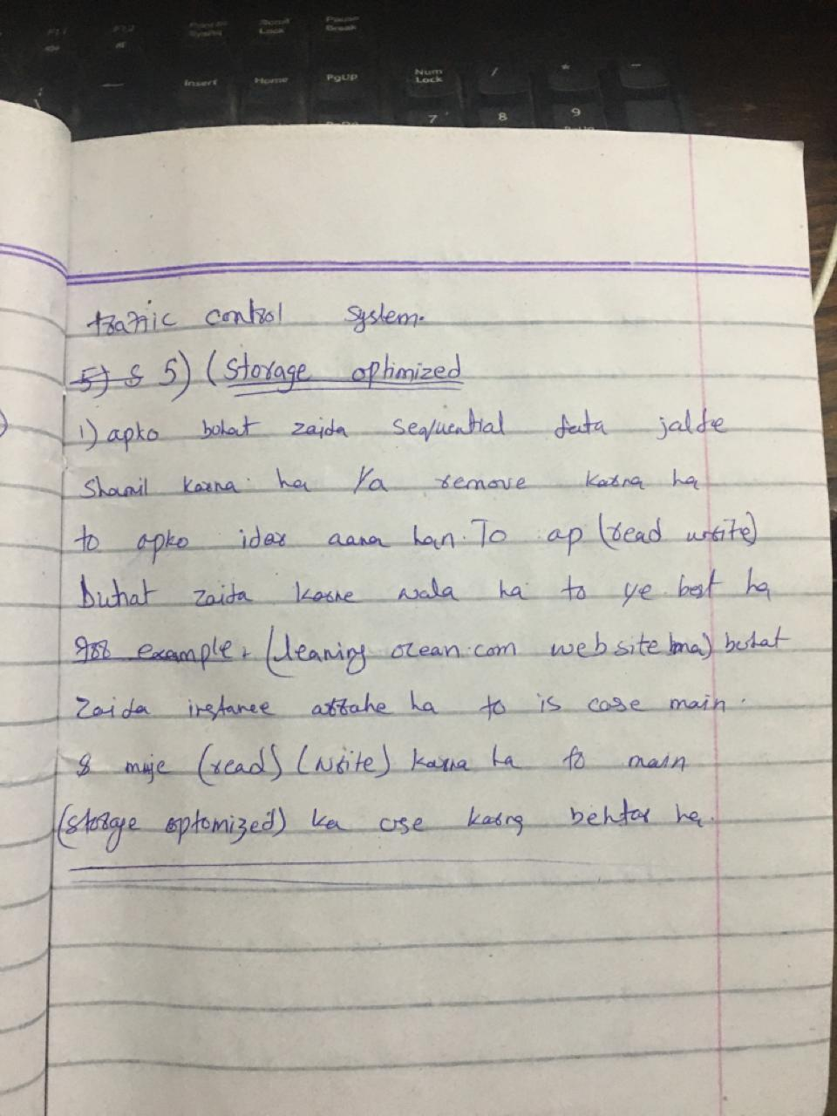

**AWS Tutorials - 17 - AWS Pricing | Reserve Instance | Spot Instance | Saving Plan | Dedica**

Linux or window ka case ma

//aws agr hu, 20sec chalta ha to wo 1 minute ka paisa laga//

//agr hum 80sec chlta ha to wo 80sec ka paisa ly ga hum sa//

**18 video turtorial create window instances**

Iss ma phle instance create karna ha

Fr Microsoft window select karna ha

Fr t2.medium select karna ha //t2.medium free nai ha//

Fr login key dalne ha

Fr launch instance karna ha

//ya bot slow hota ha obuntu sa //

Fr instance ko select kr ka connect pr click karna ha

Fr RDP client pr jana ha

Fr download remote desktop file pr click karna ha

File download ho gai ha

Uss ka opr double click karna ha

File open ho ge to connet pr click karna ha

Download ho ge fr password manga ge

Password rdp client ma password lekha ho ga uss click karna ha

Password wale open ho ge

Uss ma upload private key file ho ge ussa select karna ha

Jo hum na key bni ho ge ussa select karna ho ga

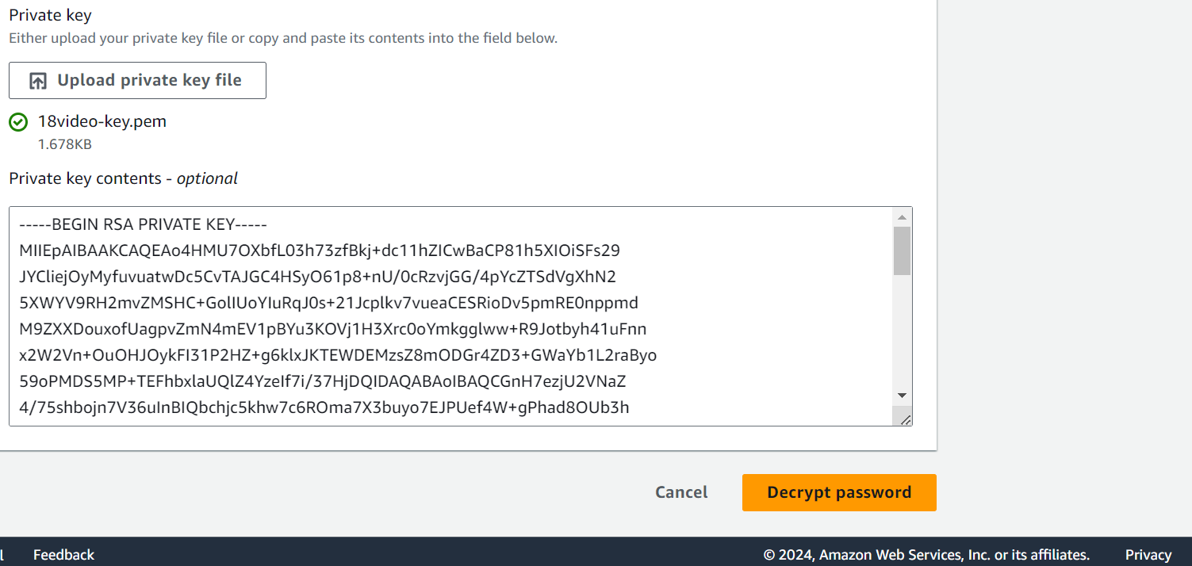

Fr ya option select karna ho ga

Decrypt password

Fr password wala option ma password aaa jaya ga

Ussa copy kr ka file ma paste karna ho ga

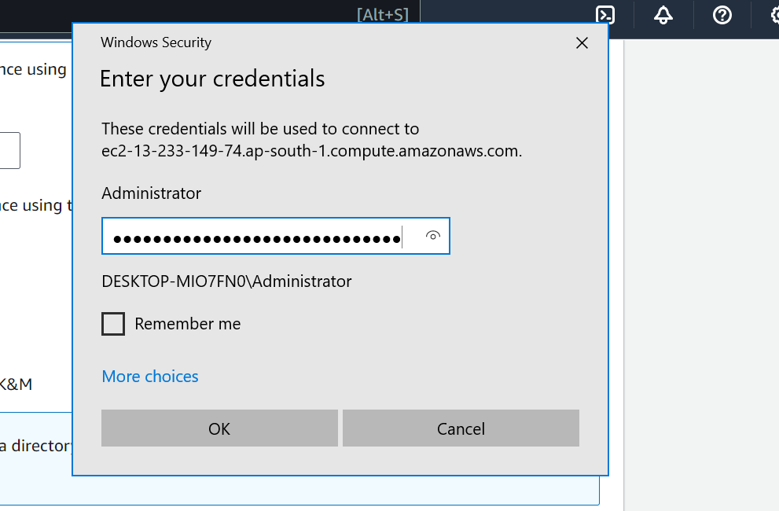

Fr ok pr click kr ka yes ka button dabanaho ga

Fr administratror onn ho ga or window start ho ge

Fr cmd ma ya command ay ge

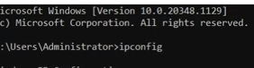

**ipconfig**

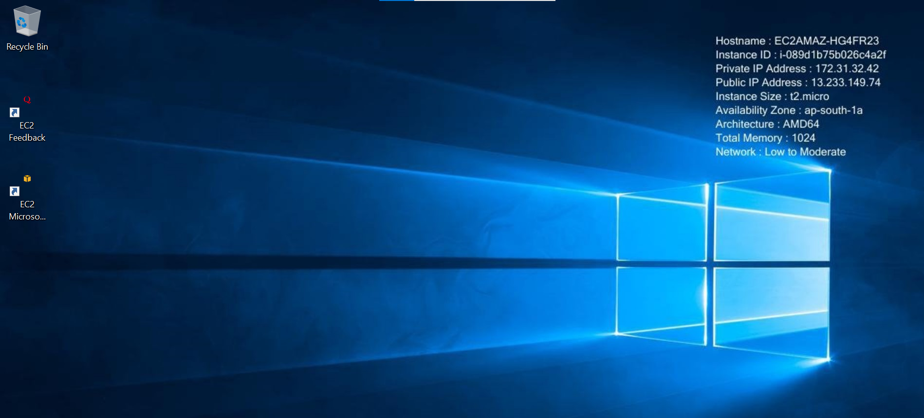

Then press exit to cancel

**19 video is ma linux sa kasa window bnata ha**

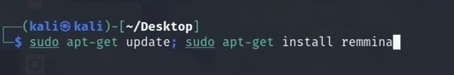

Ya video bs dakhe ha

**AWS Tutorials - 20 - Instance Metadata With UserData | AWS tutorials |**

Iss ma hum na user data email imei and other userdata leta ha etc

Instance bna ke connect pr click karna ha

Commands

1 ip a

2 curl 169.252.169.254

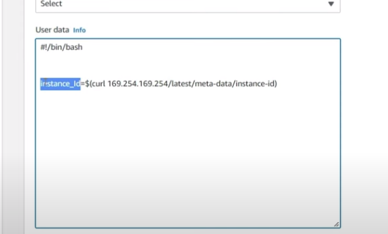

Ya ip video ma kam kr rahi ha pr mare ya kam nai kr rahia

Ip address stop karo to change ho jata ha

**AWS Tutorials - 21 - Attach Elastic/Static IP to an EC2 Instance | AWS tutorials | AWS**

/// is sa ip address permanent rahta ha or change nai hota instance hum stop ya reboot karaa to ip address change nai ho ga///

Phle instance create kea ha

Fr scrollbar jo side pr ha uss ma network&security

Fr elastic ips pr click kea ha

Udr 1 be elastic ip nai ha

Fr allocate elastic ip address pr click krna ha

Fr necha allocate ka button pr click karna ha

Fr instance ma jana ha uss ke ip address

Dekhna ha

Fr dubara jhan elastic ip create ke ha wha jana ha

Uss ma ja kr action pr click kr ka

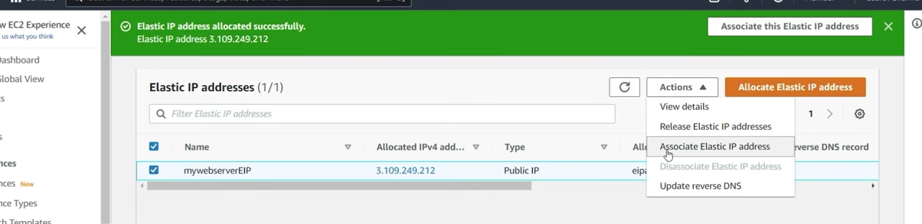

Asssocites pr click karna ha

Fr choose instance karna ha wo automatically

Option ma aa jaya ga

Fr apna private ip address be dal sakta ha

Fr asssocite ka button pr click karna ha

Fr instance pr ja kr click kr ka connect kr sakta ho

.///ya ip address ko static rakhta ha//

//Nai to ip address change ho jata ha//

Ya isss lea b kam ate ha ka 1 address([www.learningocean.com](http://www.learningocean.com) )ya or koi link ka address ka ip idress ko static mean(123 ya ip ha ya server ko reboot ya koi masla hona pr dobara change na ho)

5 ip address hum reserve kr sakta ha (only five)

Five sa zayda be hum ip address resereve kr sakta ha pr us kale huma email bajne parte ha//

1sa zayda ip address lena sa aws paisa la ga//

# AWS Tutorials - 22 - Detach Elastic/Static IP | Release EIP

# Iss video ma hum elastic ip ko delete ya release kr sakta ha ip ko select kr ka action ka upr click karna ha fr

# Release ip address pr click karna ha

# Fr release ka button pr click kr ka release kr sakta ha

# //// ya tb tak release nia ho ge jb tk wo kisse instance ka sat attach rahte ha ///

# AWS Tutorials - 23 - Elastic Block Storage (EBS) | Instance Store | AWS Step By Step

// Ebs work like a harddisk or to store data //

///ya ak hardisk ha jo hum apni machine ka sat attach krwa raha ha//

Hum ak machine ko muktlif volume ka sat attach kr sakta ha

Hum volume ka size again increase kr sakta ha

Ebs availibilty zone ka andr hota ha

Hum ak zone sa dosra pr ebs la kr ja sakta

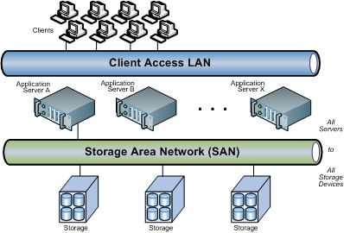

Hum na 1 ec2 voume bnaya ha kia hum ussa multiple ec2 instance ka st connet kr sakta ha

Anser yes/no

Ebs ma hum 5ya 6 volume create kr sakta ha

Two 2 type ka volume hum multiple instance sa

Attach karwa sakta ha

Or baki ka 4 ko ak(1) instance ka sat attach krwa sakta ha

Jab be hum koi be ebs volume create karta ha to

Wo availability zone ka andr lock hota ha

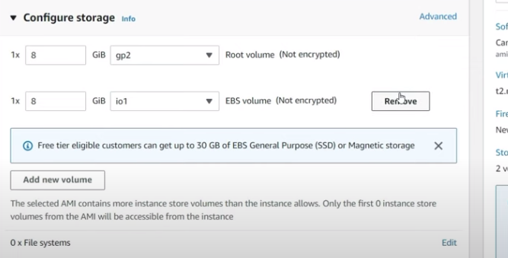

Is sa new volume create kr sakta ha

//io1 or io2 ko hum multiple instance ka sat connect karsakta ha//

///

1 ami ma gya]

2 search ubantu kea

3 on by me sa ….>>>>public img select ke

4 ak filter open ho gay ga

# AWS Tutorials - 24 - Create First Elastic Block Storage Vol | Mount EBS in Linux |

1 first goto ec2 dashboard

2 side pr slider ma go to elastic block store

3 volumes ka andr jana ha

4 create volume pr click karna ha

5 7 type ka volume hota ha

6 select gp2 volume

7 select size of volume (ma na 1 gb rakha ha )

8 then select create volume

9 2 volume create kr ka dashboard pr chale jana ha

10 fr launch instance pr click karna ha

11 instance ka bad network setting ma jana ha

12 fr edit pr click karna ha

12.5 fr subnet pr click karna ha

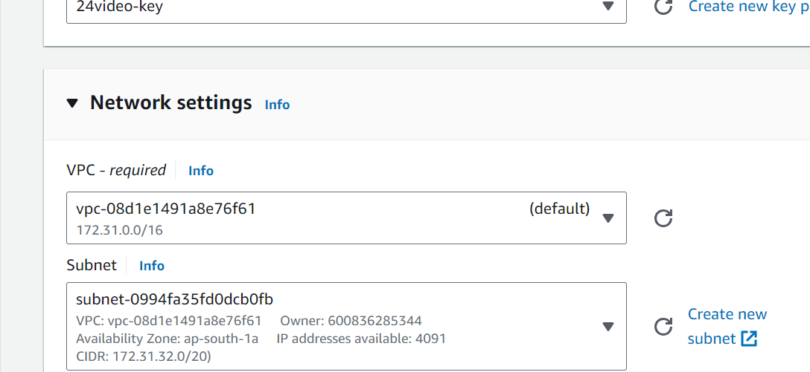

14 ak koi select kr lo ma na south 1a ke ha

15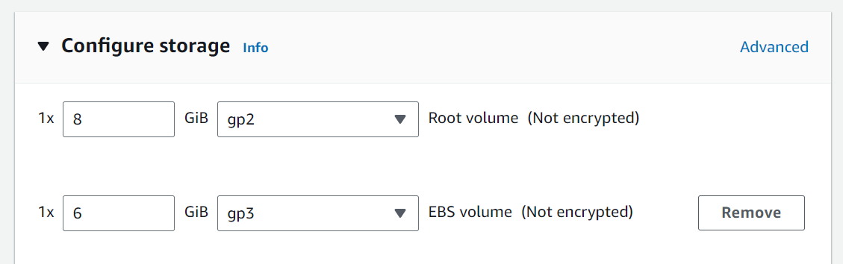

16 ak or storage create kr lea ha

17 launch instance pr click kr do

18 fr volumes pr click karna

19 volume ka andr 2 volume create ho gay ga

20 fr uss instance pr jana ha or connect karna ha

21 lsblk ya command dalna ha

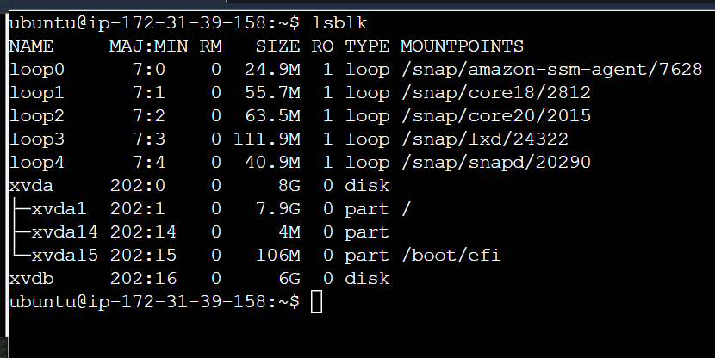

23 iss terha show ho ga

24 fr elastic block store ma volume ka andr dobara jaana ha

///attach volume in ebs

25 volume ko select kr ka action pr click karna ha or uss ma attach volume pr click karna ha

26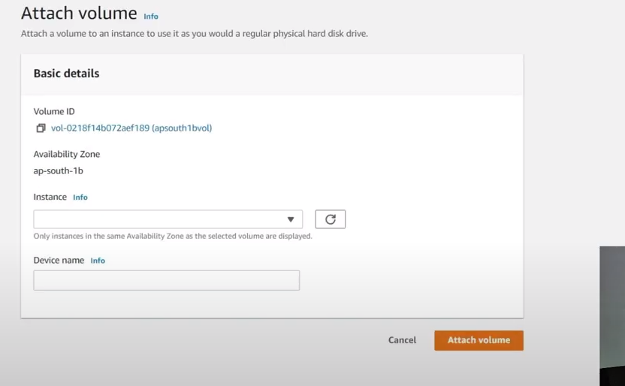

27 iss terha open ho ga

28 to phle box pr click karna ha to instance khud show ho ga ussa select karna ha

29 ap south a wala a volume ko he attach ho ga nai to box ma koi instance show nai ho ga

30 fr attach volume ppr click karna ha

31 fr command connect pr chalane ha (lsblk)

// how to detech volume in ebs//

1 suppose huma koi ak volume detech karwana ha

2 volume ko select kr ka action wala button pr click karna ha

3 detech wala ko select karna ha

4 jo hum na khud volume banay ha wo he detech ho ga default wala volume detech nai ho ga

5 fr sa command chalata ha (lsblk)

6 iss command sa wo format karta ha is command ma sudo dalta ha phle muja yadd nai raha dalna ke

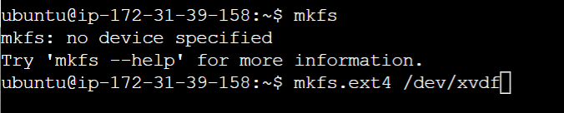

7 fr sudo !! command dalta ha

8 fr mkdir /test ya command dalta ha

9 sudo !! dalta ha dobara

10

Extra code from chatgbt///////cat /var/log/syslog

sudo !!

sudo cat /var/log/syslog

# 10 sudo su

# 10 Cd /

# 10 ls

# ///is ka bad video ke koi command nia sai chale

# AWS Tutorials - 25 - Detach an EBS volume from one EC2 Instance and Attach it Another One

//is ma hum ebs volume ko ec2 instance ka sat connect karna ha///

1 instance create karta ha

2 ubantu>keypair dalta ha

3 networksetting ma ja kr edit pr click kr ka subnet pr click karta ha

4 subnet ma option aa jata ha 24 video ma jo hum na volume bnay tha unaa

5 fr ak koi select karna hota ha

6 launch instance kr deta ha

7 fr connect pr click karna ha

8 slidebar ma Elastic block store>> volume pr jata ha

9 volume us ka bna tha mera ma na delete kr dea the ja ka dobara bnana ha 1 ap-south-1a

Or 1 ap-south-1b ma ho

10 1a wala ko select kr ka action wala button pr click karta ha or uss ma attach wala button ko click kar deta ha

11 us ma instance ka box ho ga ussa pr click karna ha wo khud option da ga ap na select kr lena ha

12 attach volume button pr click kr dena ha

13 connect pr ja kr command {lsblk } lekhta ha

14 sudo -s /dev/xvdf

15 fr ak or volume ko attach krwa deta ha

// ap-sout 1a wala 1a sa attach ho ga ap south 1b wa 1b sa attach ho ga///

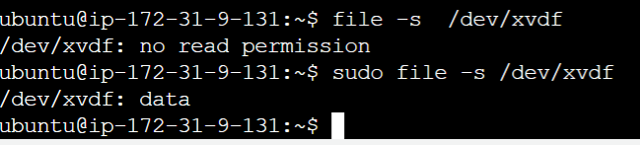

16 mkdir /data

17 mount /dev/xvdf /data

Cd /data/

Ls

Cat demo_for_youtube.txt

// us ma hamara data welcome to learning ocean aa jaya ga//

**AWS Tutorials - 26 - Resize EBS Volume and Resize the File System**

// is ma hum ak volume ka size increase kr sakta ha //

1 volume pr jana ha ussa select kr ka

2 action pr click karna ha >>modify volume pr click karna ha

3 size ma ja kr 5 ko ap jitna marze increase kr lo

4 fr modify button pr click kar lena

5 command ma lsblk

6 df -h

7 ya command file ko resize karna ka lea ha command{resize2fs /dev/xvdf}

8 Df -h//is command ka bad iss ke space increase hogi ha

**AWS Tutorials - 27 - How to Resize ROOT EBS Volume**

1 launch instance

2 select instance

3 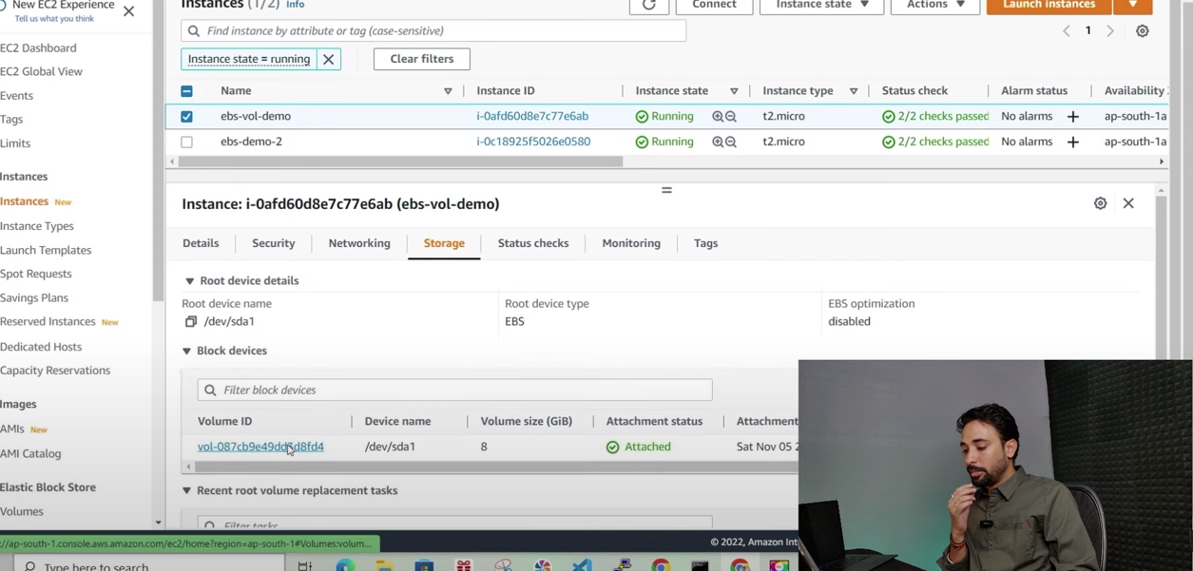

4 instance ko select kr ka uss ka necha detail wala box open ho jata ha uss ma storage ka option att ha ussa select karna ha

5 uss ma volume id ko click karna ha

6 fr new page open ho jay ga uss ma ussa select kr ka action pr click karna ha

7 modify volume pr click karna ha

8 ap na jitna be volume increase karna ha

9 modify wala button pr click karana ha

10 instance pr ja ka connect pr click krata ha

11 command {lsblk}

12 connect ma xvda ka size increase ho jay ga

13 df -h

14 sudo file -s /dev/xvda1

15 sudo resize2fs /dev/xvda1//is sa noting to do lekha aaa jay ga

16 sudo -i

17 growpart /dev/xvda 1

18 lsblk

19 Df -h

20 resize2fs /dev/xvda1

21 df -h

.// jo hamre command ho ge{ xfs growls

**AWS Tutorials - 28 - Attach One EBS Volume to Multiple EC2 Instance**

// is ma hum ak instance ko different volume ka sat attach kara ga //

1 instnace create karta ha

2 side pr option right pr hota ha uss ma summry ma num of instance pr 2 kr dena ha 2 instance create ho gay ga

3 ak instance ko select kr ka connect pr click karna ha

4 2 instance ko be selct kr ka connect kr leta ha

// dono ke connect file alagg alagg ho ge //

5 volume pr ja kr ak new volume create karta ha

6 volume ma io2 select karna ha phle box ma jhan (volume type ha)

7 jab hum io2 to select kara ga to ::multi attach ka option aa jay ga

/// kuch regions ma io1 ka sath multi attach available

Hota ha ////

8 uss ka size 5gb ya so onn ----gb leta ha

9 enable multi-attach (ka checkbox ko select kr leta ha

10 fr create volume ka button pr click kar deta ha

11 fr volume pr jata ha to volume selct karta ha to error aaa jata ha t2 ma

12 fr instance pr ja kr instance state> stop instance kr deta ha

// instance ko stop kar ka hum instance type change kr skata ha nai to hum nai change kr sakta instance type//

13 instance stop ho jata ha to tab ja kr action button pr click karta uss ma instance setting pr jata ha us ma sirf ak instance ko select kr ka us ke instance type t3 micro kr deta ha

Fr dosra ke be iss terha ho ge

14 instance stop tha un ko instace state > kr start kr deta ha

15 ab wapis ebs volume ma chala jata ha

16 uss ke ebs ma error aa jata ha

17 fr sa new volume banata ha or un ko selct kr ka attach kr deta ha dono instance alag alag attach ho ga instance sa .

18 hum ko us instance ko slect kr ka scroll karna ha fr hum pta chala ga ka kitna instance sa connect ha ya

19 fr demo 1 or 2 ka connect ma{lsblk }chalta ha

// ap ko is ma asa file system istamal karna ha ja cluster aware ho//

# AWS Tutorials - 29 - Type of EBS Volumes - Which EBS Volume should I use ?

Reading wala tuturiol ha

// input or output operation huma karna ho to (io1 and io2)volume ko select karna ha //

//gp2 or gp3 ya general purpose ha//// is ka andr aws balance kr ka deta ha price or speed ka beach ma//

Gp3 ma hum input output speed(iops) 3000 sa lakr 16000 tak la sakta ha iops

// aws ma option ha volume type login hona sa phle wala page us ma huma pta chala ga ka huma kiss type ka instancetype chai etc

///

**AWS Tutorials - 30 - Snapshot Overview - AWS Snapshot - EBS Snapshot**

What is snapshot

/// agr koi data hum na bna lea ha or hum na snapshot lea ho or koi hum sa data ma error aa jay to hum snapshot ke maddad sa revert kr sakta ha//

/// snapshot s3 bucket ka andr store hota ha//

Example{

Hamra pass 100 gb ke storage ha ak din ma 50 gb data store ho gya or hum na snapshot la lea to hamara pass 50 gb raha gya agllaa din 10 gb or data aa gya to aws agla 10 gb ka snapshot la ga or total 60 gb full ho gay ge

///50 gb phle wale already save the uss ke snapshot us ka pass mojud the wo agla 10 gb ke snapshot la ga

Doublicate data nai hona da ga//

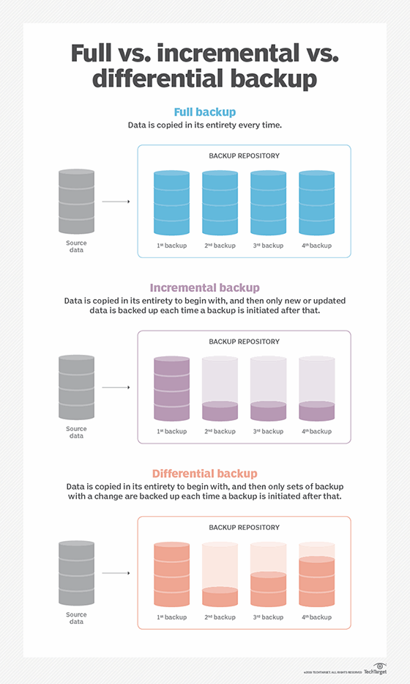

# AWS Tutorials - 31 - Create First Snapshot - EBS Backup

1 launch instance

2cofigure storage ma ak storage bnata ha

3 launch instance kr deta ha

4 ebs volume ma chala jata ha

5 lsblk

6 file -s /dev/xvdb

//no read permission//aa jay ga

7 sudo -i

8 file -s /dev/xvdb

9mkfs.ext4 /dev/xvdb

10 mkdir /data ////ya directory banaa ka kam atee ha ////

11 mount /dev/xvdb /data

12 mountpoint /data

13 cd /data/

14 ls

15 clear

16 yes “anjum”>> abc.txt ////yes command ak loop chala date ha ////

17 ls -1h

18 df -h

19 volume ma ja kr select kr ka action >create snapshot pr click karta ha

20 description ma name add karna ha

21 create snapshot kr deta ha

22 snapshot ma hamara snapshot ban chuka ha

23echo “this is a new file in ebs volume” > /data/xyz.txt

24 cd /data

25 ls

26 ls -h

// ab snapshot sa ak or volume banata ha

1 snapshot ko select kr leta ha

2 action pr click karta ha >>>create volume from snapshot pr click karta ha

//hum volume ko kam nai kr sakta zayda ho ga kam nai//

3 volume ka size deta fr create kr deta ha

4 volume ka andr jata ha waha ak new volume ban jata ha snapshot sa

5 volume ko select kr ka attach krwa deta ha

6 lsblk

7 file -s /dev/xvdf

8 cd ..

9 mkdir /dataone

10 mount /dev/xvsf /dataone/

11 cd /data  
12 ls

13 Cd /dataone/

# AWS Tutorials - 32 - Automate EBS Volume Backup - EBS Lifecycle Manager - EBS Backup

1 volume create karta ha

2 tag pr click karta ha //volume ko select kar ka necha sa ak box open ho ga uss ma (Tag ) ka option ho ga// is ma koi or kam nai kea uss na

3 lifecyle manger pr jata ha //side ma jo sidebar uss ma//

4 volume ko selct rana dena ha

5 target resource tags pr jana ha//is ma tag name automatically aa jay ga

6 jo atta ha una select kar leta ha

7 fr first ma(tier type name deta ha )dosra box ma (database name deta)// is ma koi kam nai karta iss delete kr deta ha bna ka//

8 policy description ma name deta ha

9 baki sara default chor deta ha

10 is ma hum ko schedule btana ha ga

11 uss ma relation type btata ha (count) select karna ha

12 keep (is ma ap btaa sakta ha kitna snapshot ap ka pass store hona chayaa//)

13 baki sari cheza default chor dane ha

14 next page ma create policy ka button pr click kar deta ha

15 snapshot 2 hour bad ay ga jo hum na time set kea tha

16 delete kar deta ha sub kuch

**AWS Tutorials - 33 - Snapshot and AMI Recycle Bin - Recycle Bin for Snapshot and AMI AW**

1 snapshot ma recycle bin ka option ha uss pr click karta ha

2 name btata ha

3 retention type (ebs snapshot ko selct kar leta ha )//ya recyle bin banana ka kam ate ha//

4 apply to all resource ko select kr leta ha

5 is ma hum 1 year sa la kr 1 day tak ka time rakh sakta ha

6 fr create retension tule kr deta ha

66 volume banak r action pr click karna ha

7 volume ma ja kr us ko selct kr ka action pr click karta ha us ma create snapshot pr click kar deta ha

8 name btata ha fr create snap shot pr click kar deta ha

Snapshot ma ja kr jo hum na snapshot le ho ge uss delete kar dane ha wo snap shot recycle bin ma jay ge

9 recylbin pr jana ha //agr ap ko recover karna ha to select kar ka recover kar dena ha

**AWS Tutorials - 34 - Copy Snapshot From One Region to Another- Copy Snapshot Cross Region/Account**

//region cheak karta ha(us na volume banaya tha phle fr uss ka region or change karta ha to hide ho jata ha fr dobara use region ma atta ha to wapis aa jata ha ///

2 volume ma ja kr volume create karta ha

3 volume type ma ja kr io1 select karta ha

4 necha checkbox ma (enable multi- attach ko select karta ha )

5 uss ke snapshot be creat hoi ha

6 snapshot ma jata ha fr action ka button pr click karta ha uss ma copy snapshot ka option ho ga ussa click karna ha

7 hum uss ma region select karna ha

8 apna or iss snapshot ka region same nai hona chia

9 check box ma encryption ko slect kr la ga

10 uss region ma jata ha or whaa snapshot nazar ata ha

11 uss ko slect kr ka action pr click karta ha >>

Create volume from snapshot ko click karta ha//iiss line pr uss na kam nai kea skip kr de the

**AWS Tutorials - 35 - Encrypt the EBS Volume - What will happen when we encrypt the**

خفیہ کاری encryption

1 volume create karta ha

2 checkbox ma encryption ko select kar leata ha

3 kms key description ma default select kar leta ha

4 ak taG ADD KARTA ha

5 tag first box ma (name ) second box (encrypted-vol) lektha ha

6 create volume kar deta ha

7 // ak or volume banata ha uss ma wo encryption ko nai select karta tag ma name value dalta ha //

//agr hum kisse encrypted volume ka snapshot banata ha to wo encrypted lekha ho ga or unencrypted ma unencrpted ho ga//’

8 encrypted vala ka snapshot banata ha

9 name or create kr deta ha

10 unencrypted vala ka be snapshot banata ha

11 snapshots pr jata ha

12 ak snapshot jo encrypted ha ussa select kr ka action>> create volume from snapshot pr click kar deta ha

13 agr hum kisse be encryption volume ka snapshot bany ga to wo encryption ma he raha ga

14 fr sara kuch default chorta ha or create volume kar deta ha

15 ab unencrypted wala volumeko select kar ka >>action>> create volume from snapshot pr click karta ha

16 iss ma encryption wala checkbox show ho ga

17 volume create kar deta ha

18 // agr hum koi be data addd kara or wo encrypt khud ho jay to

Ec2 console ma jana ha

Setting ho ge right side pr ak box ma

Setting>>>ebs encryption pr click karna ha

Fr mange pr click karn ha

Enable ko select kr lena ha checkbox ho ga

// ya hum koi be volume bany ga to by default ya khud he encrpt ho gay ga//

**AWS Tutorials - 36 - Delete EBS Snapshot - Cleanup Snapshot**

///is video ma sara snapshot ko delete karna sekhta ha //

# AWS Tutorials - 37 - AWS AMI - Amazon Machine Image - Create your Own AMI

Ya snapshot ke setting ha

// phle video ma snapshot pr click karta ha action ma ja kr (manage fast snapshot restore) pr click karta ha

// sara snapshot ka checkbox ko select kr ka enable kar deta ha //

Now about ami (amazon machine image)

14 video turturiol ke example deta ha jiss ma hum welcome to learning ocean dalta ha phle nginx aa jata tha

// is ami ma nginx automatically install hota ha

Or nginx install hona or dosra time waste nai hota //

1 phle instance create karta ha

2 allow http traffic from internet

3 instance ban jat ha

4 connect kar ka {sudo su

{apt-get update;apt -get intall nginx -y}

{service nginx status}

{cd /var/www/html/

{ls}

{ vi index.html

{curl localhost}

// ab hum is instance ke img bnata ha //

1 instance pr jat a ha right click kar ka (image and templates pr jata ha

Another example

Instance ko select kar ka action pr jao>>> image and templates >>

2 volume par ja kar ak volume ka snapshot leta ha

3 snapshot ma ak kisse ko select >> action>> create image from snapshot

1 instance ko select kar ka action ma >>image from snapshot >>create snapshot

2 image ka name deta ha

3 baki sara default chor deta ha

4 create img ka button ko click kar deta ha

5 sidebar ma ami par jata ha wha uss ka ami create ho jata ha

// img create hona ma time lagta ha 15 to 20 mint//

Is ami sa hum instance create kar sakta ha

1 ami ko selct karta ha fr launch instance from ami ka button pr click kar deta ha

2 launch instance kar ta ha

3 ubantu ke jaga ma my amis ko select kart aha

4 allow http from internet be selct kar leta ha

5 advance detail ma >>> user data >>>

#!/bin/bash

Service naginx start

6 launch instace pr click kar deta ha

**AWS Tutorials - 38 - Share Your AMI with other AWS account - Delete Your AWS AMI**

How to share ami with other

1. ami ko select karta ha
2. action pr click karta ha
3. edit ami permissions pr click karta ha
4. shared account ma ja kr uss ke id dal sakta ho or us ka sat share kr sakta ho
5. agr ap ko apni ami ko private sa public banana ha to ap private sa public ka check box ko selct kar sakta ho

copy ami process

1 ami pr jana ha usssa select kar ka

2 action>>copy ami pr jana ha

3 is ma ap apni ami ko copy kar ka dosra region ma kar sakta ho

4 then select copy ami button

/// us na issa cancel kar dea ha//

Now how to delete ami

1ami ko select karna ha

2 action ma ja kara >> deregister ami pr click kar dana ha to ami delete ho jay ge

3 fr snapshot par jana ha fr instance ko select kar ka >>action>>delete snapshot kar dena ha

**AWS Tutorials - 39 - Elastic Load Balancer in AWS (ELB) - Classic Load Balancer(CLB)**

//ya elb server par load balance karta ha

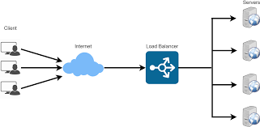

1. sidebar ma loadbalancing ka option hoga
2. loadbalancer pr click kar deta ha
3. then click on create load balancer
4. aws 4 type ka load balance show kARta ha

* application lb
* Network lb
* Gateway lb
* Classic lb

Now we start from classic load balncer

/// ya sab sa purana wala load balancer ha //

1 phle hum na four ec2 instance create karna ha

//hum na instance different server par banana ha

**First instnance**

1. Phla instance ka default raha ga
2. User data ma

(#!/bin/bash

Apt-get update

Apt-get install nginx -y

Echo “this is $(hostname)” > /var/www/html/index.html

1. inbound security group rule ma
2. add security group rule ko click karta ha
3. fr http
4. or dosra anywhere ko select karta ha
5. avalibilty zone be check karna ha ka same na ho
6. fr instance create kar deta ha

**second instance**

2 instance ya ha

1 instance create karta

2Network setting>> subnet>>Region south

1b

1. Allow http traffic from the internet

4 user data ma

User data ma

#!/bin/bash

Apt-get update

Apt-get install nginx -y

Echo “this is $(hostname)” > /var/www/html/index.html

1. launch instance

**third instance**

same instance as instance 2

1 load balancer

2 classic load balancer pr click karta ha

3 create ka button pr click kar deta ha

1. load balancer ka name dena ha
2. creat lb inside default select karna ha
3. check box koi be select nai karna
4. sab sa neecha loadbalancer protocol
5. 
6. Fr add ka button pr click kar dena ha
7. Fr hum na create a new security group banana ha

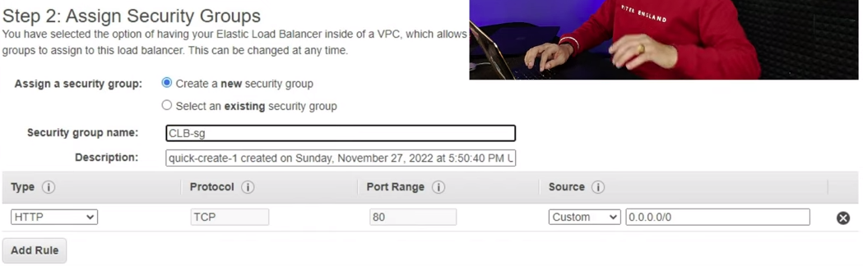

1. then select next configure…….. button
2. next configure
3. 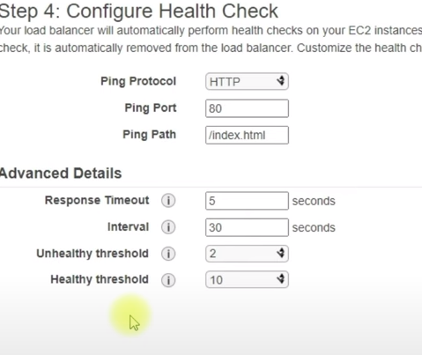
4. Next
5. Next ma 4 check box ko select kar dena ha
6. Then click on next
7. 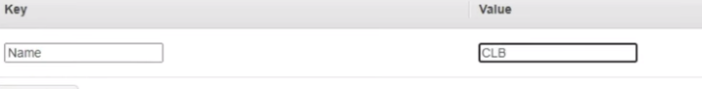
8. Then click on create
9. Web ma iss ka ip copy kr ka google ma paste karna ha then search
10. Fr bar bar refresh karn ha
11. Uss ka number change hota raha ga

# AWS Tutorials -40 - EC2 Instance Accessible by LoadBalancer Only | Access Webserver via LoadBalancer

1 phle instance pa jata ha

2 ussa select karta ha

3 security ma jata ha

4 edit inbound rule ma jata ha

1. or dosra wala ko delete kar deta ha
2. 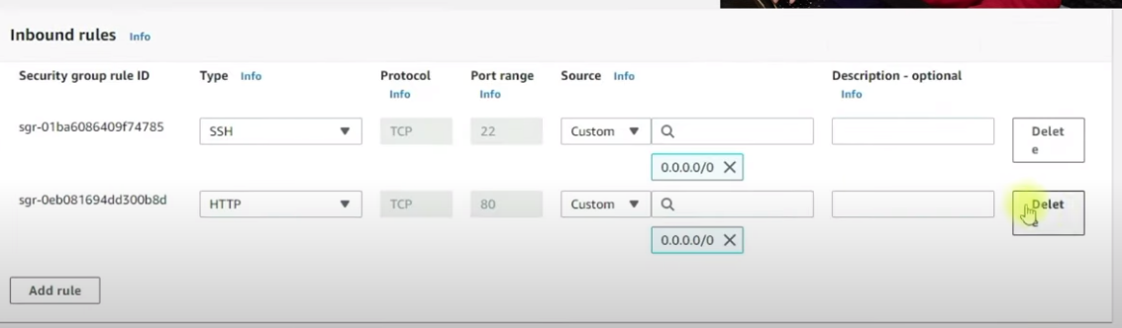
3. Delete kar ka save rule pr click kar deta ha
4. Ab 3 wala instance ma jata ha uss ka be 1 delete kar deta ha
5. Ab 2 wala ma sa be http wale rule delete kar deta ha
6. 3ino instance sa http remove kar deta ha
7. In sa screen wala number nai change ho ga
8. Loadbalancer ka andr jata ha
9. In ka sara instance out of service ho jata ha
10. Instances ma jata ha
11. 1 instance ma jata ha or select kar ka uss ka security group ma jata ha or ussa edit karta ha
12. Edit inbound rule karta ha
13. Fr add rule pr click kar ka http wala select kar leta ha
14. Custom ka aga wala box ma hum na apna security group ka traffic ko attach kar dena ha
15. Save rule pr click kar deta ha
16. Fr load balancer pr jata ha
17. First instance inservice aaa jata ha
18. Baki ka 2 instance ha un ka be rule change kar deta ha
19. 3ino inservice aa jata ha or number change ho raha ha